Q. Take a data set of your choice and analyse it or perform some operations on it

To complete this task or for analysis we require a data set i am using various datasets but the major dataset is cardekho_cleaned.csv and minor datasets are All_cars_dataset.csv, world-happiness-report-2021.csv and responses(1).csv (since we cant perform all operations on a single dataset because every operator have some limitations) . The All_cars_dataset data set contains all data of 150 cars such as there name , emi ,mileage, price ,fuel type etc .cardekho_cleaned.csv contains 19544 records about car. world-happiness-report-2021.csv data set contain happiness report of all countries in 2021. The responses(1).csv dataset contains responses of peole about have they done particular thing or not.This Responses(1).csv has survey of around 3378 people and there responses have they done particular task or not.

The tool i am using for analysis is RAPID Miner (Because of its popularity and easy to use menu(drag and drop)).So our first task is to Read our data we accomplish this task using various operator in rapid miner.

TASK 1:- Read data of dataset selected by you.

1. Firstly we have to open rapid miner by double left click or single right click on application launcher and then choosing open.



1. After opening rapid miner You see file in menu bar(at the top in left side) just click file and after clicking that you see drop down menu just click on first option whose name is New Process and after clicking new menu appears and you have to select blank process and in this way new process created.

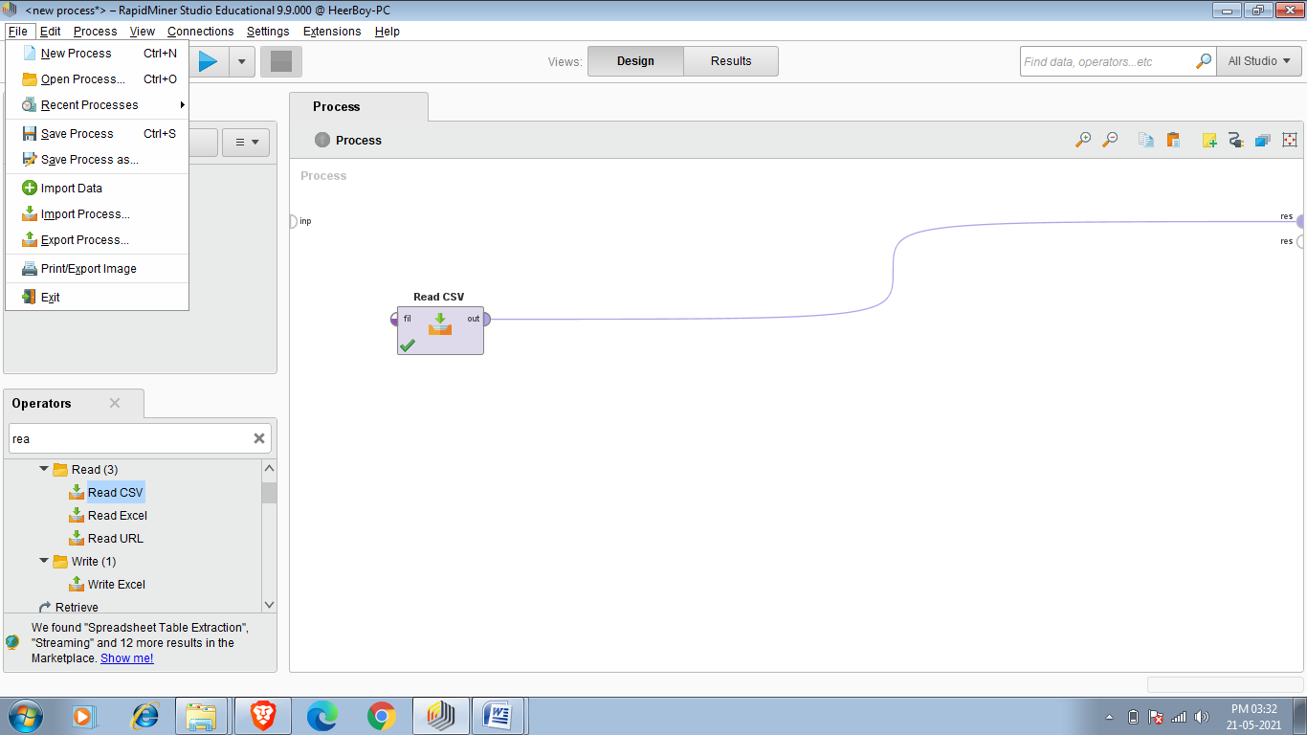

After clicking new process

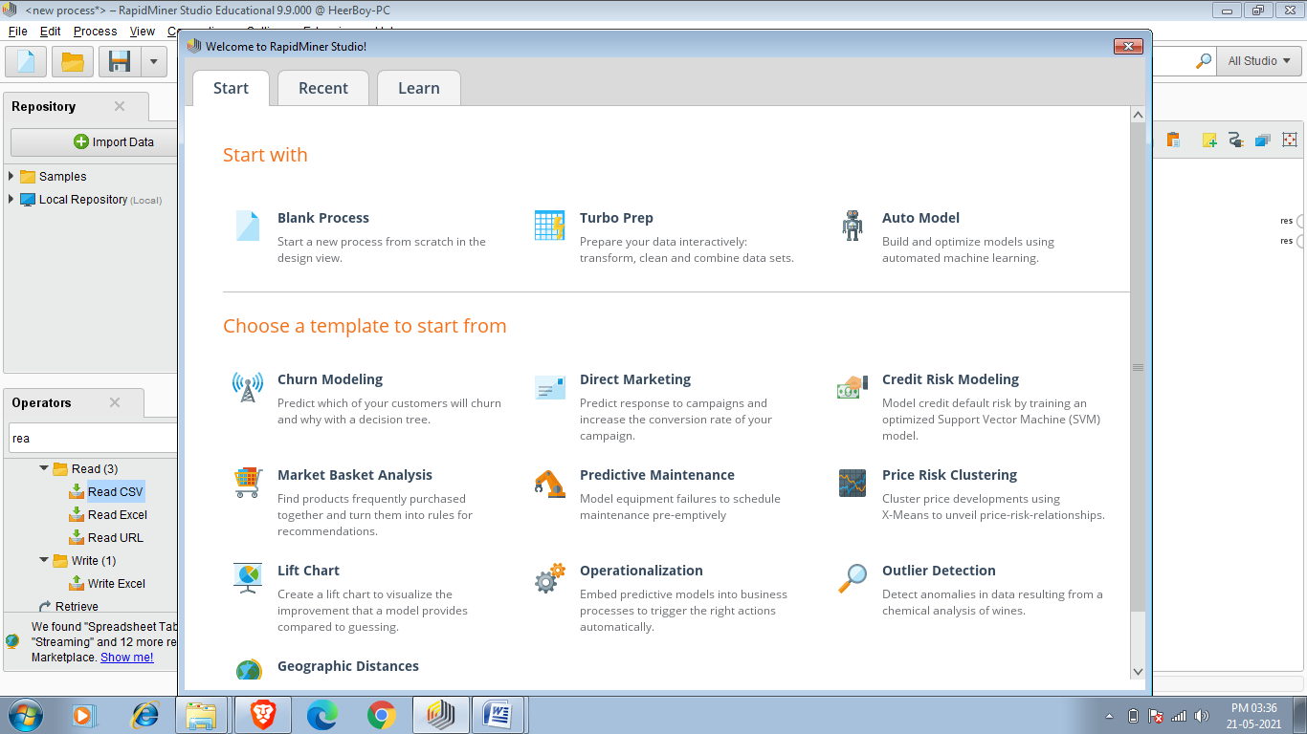

New process Created

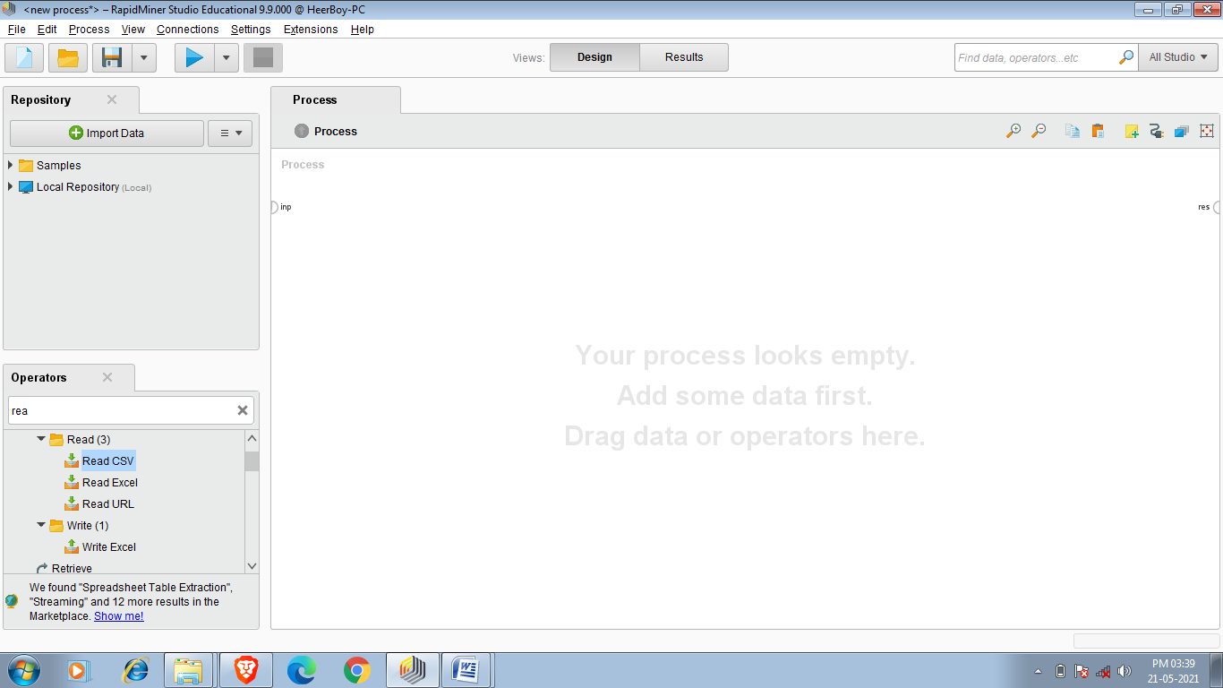

3.Now new process is created now we have to add our data (All_cars_dataset).

To add data we use operator and you see the operator column on the left at down side.In rapid miner we can read csv and excel file since required data set is in CSV (comma separated values) format so we have to type read in operator search panel after writing read it suggests us read csv, read excel or real Url.We have to drag or double click on the read csv and after that read csv operator gets added .

Read csv operator gets added

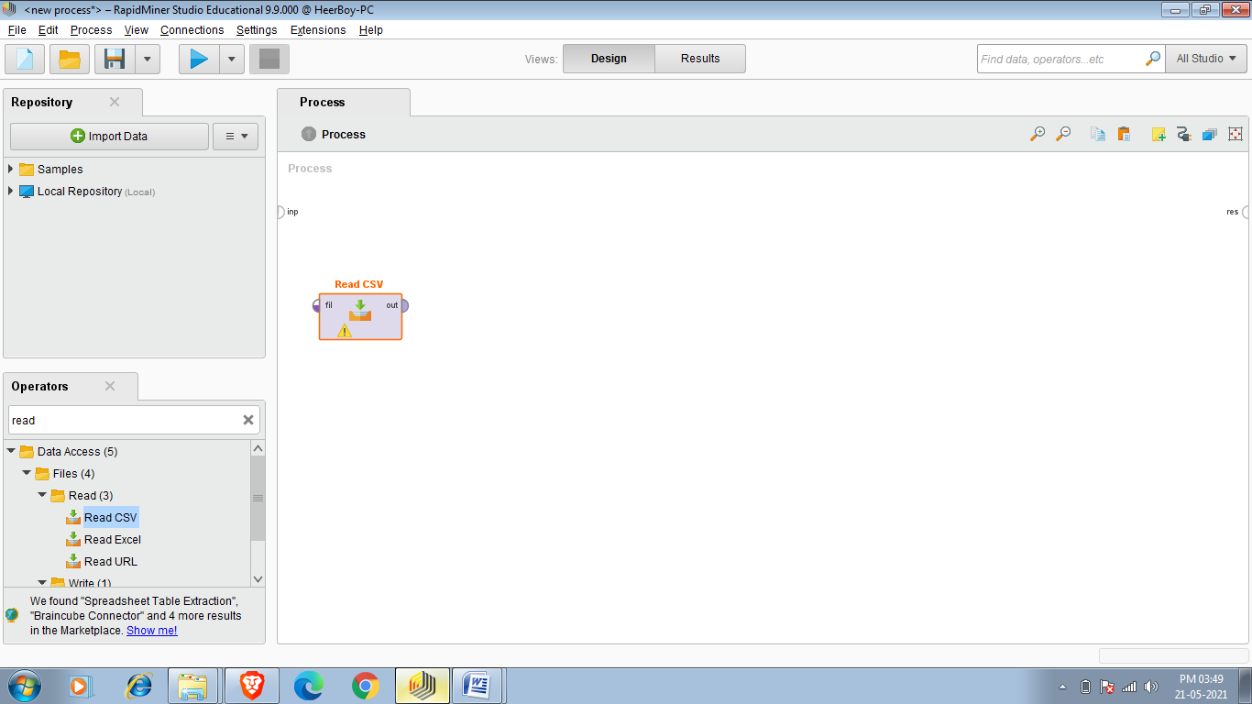

4.Now read csv operator added and our task is to choose our dataset.We have to double click on read csv operator and it shows the menu which says select the data location ,since my data is in my user’s download i have to open my download then open data sets folder(this folder contains my all required data sets) and click on All_cars_dataset.csv and them click next-next in last click on finish.In this way our we select our data set.

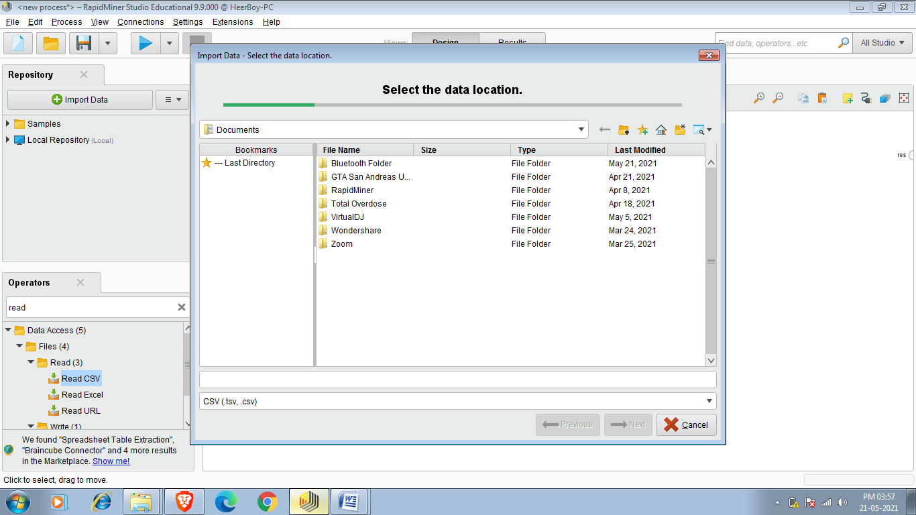

Required Dataset

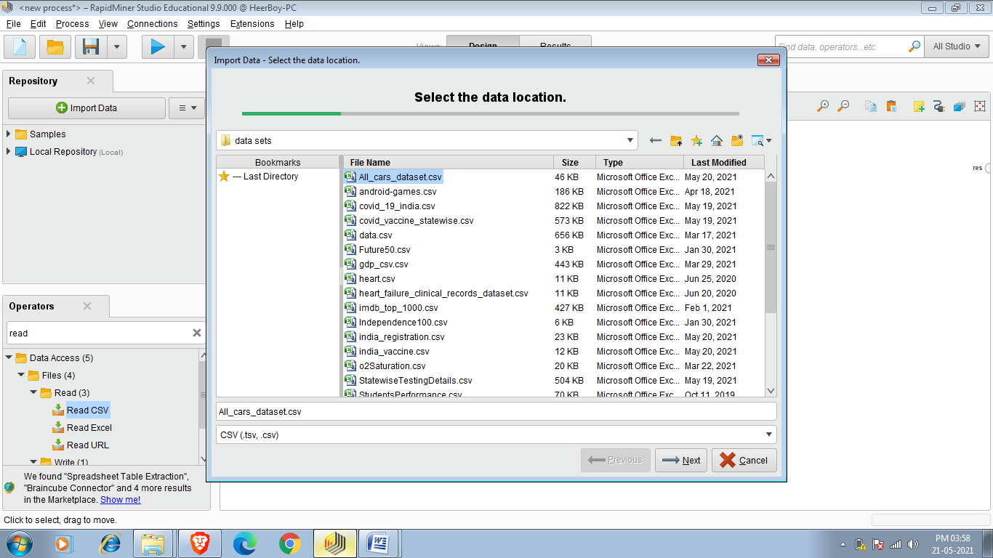

5.After selecting data set just connect read csv out to res(which is in rightmost side).Then click on 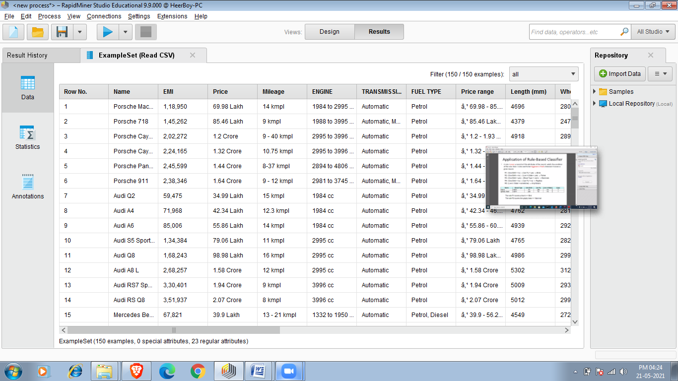 or press f11 process gets run.

click on this to run process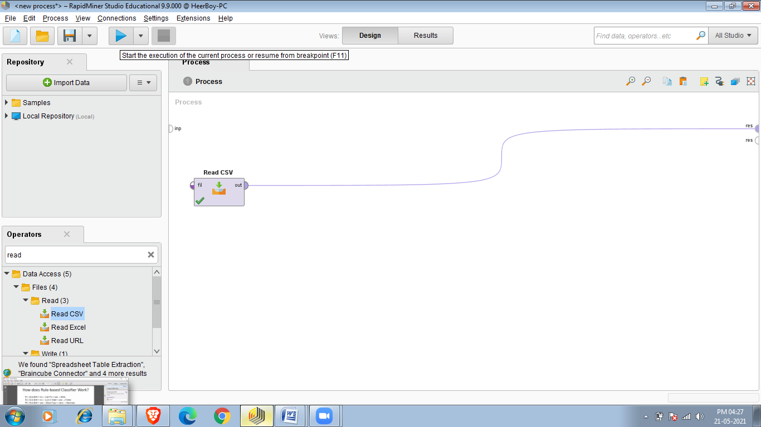

FINAL RESULT:-

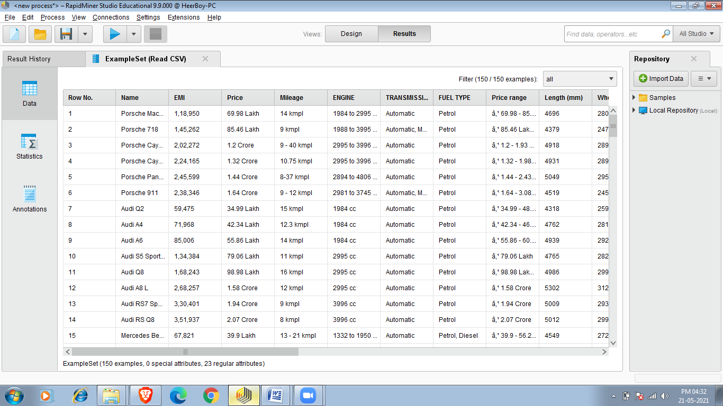

TASK 2:- Replace Missing values:-

To replace missing value in rapid miner we use Replace Missing Values operator

1.Do the same as i did in first task but now i am choosing cardekho_cleaned.csv dataset (19544 entris)after running it we saw that there is some missing values which can create some difficulty in further operations so we have to replace that missing values.

Required dataset

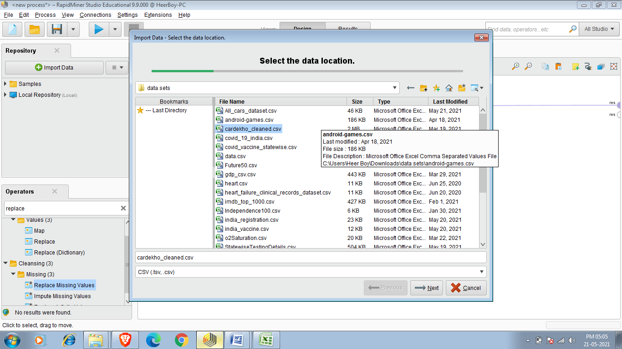

1. Click on operator search panel and search Replace Missing Values and

double click or drag it .

. 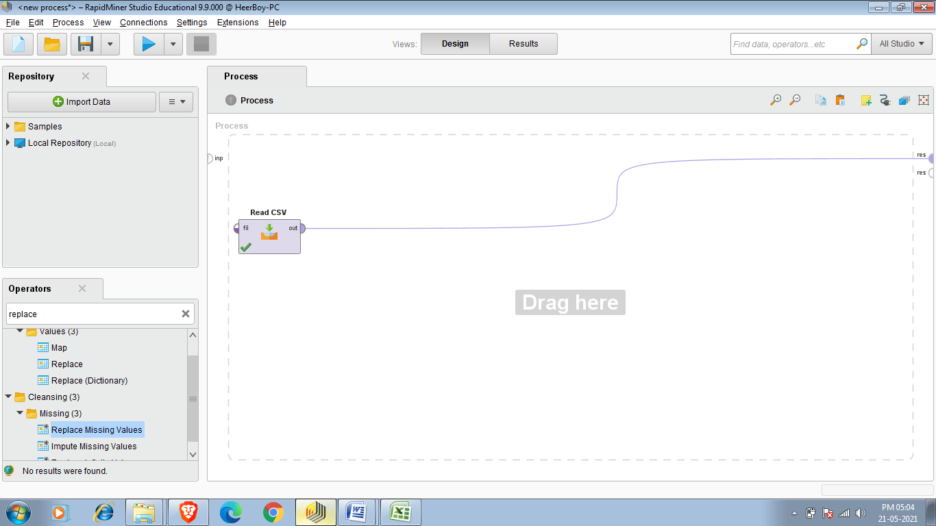

3.Connect out of read csv to exa of Replace Missing Values.

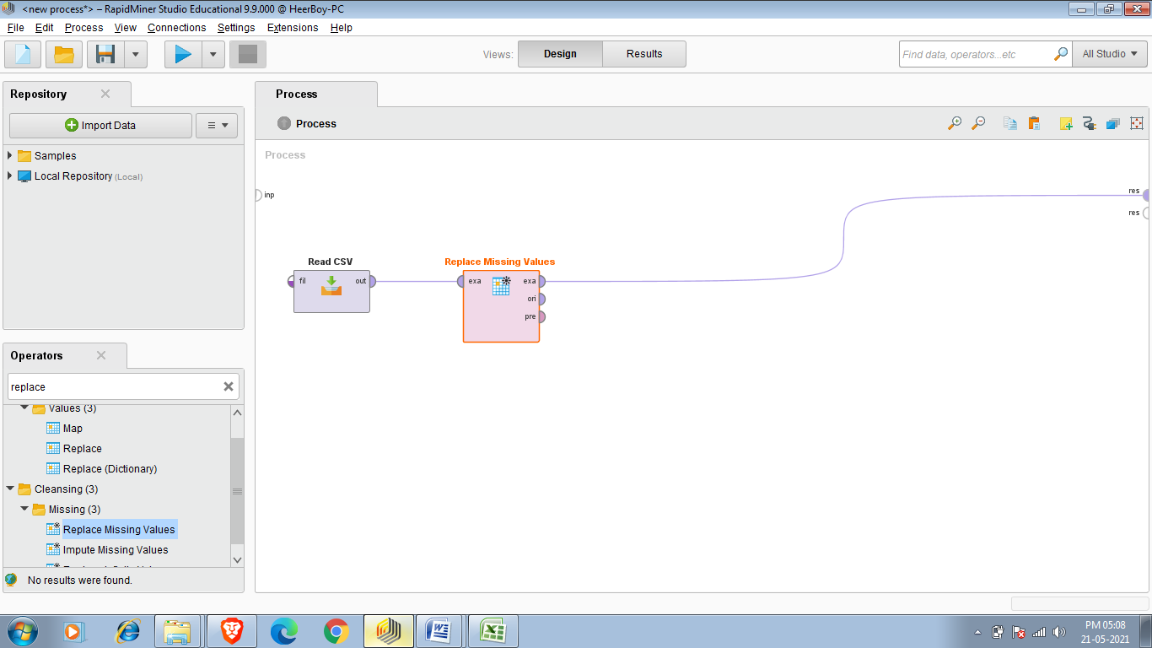

4.Connect exa of Replace Missing values to res.

5. After that run process you saw Example set which is created after replacing missing values.

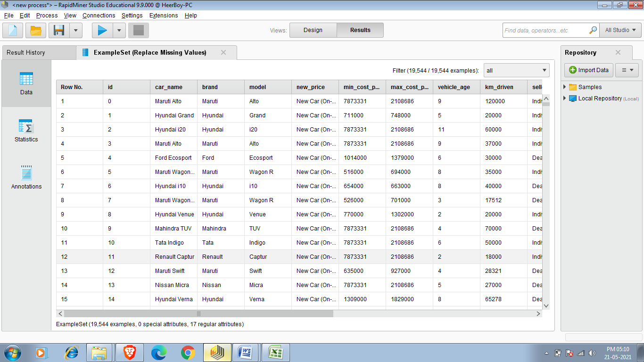

TASK 3:-Reduce number of observations

Sometimes we require only specific observations.for eg. In cars data there is attribute which contains data os seats so we only want to see those cars which have five seat or taking another example we only want to see cars data whose brand maruti.

So to complete This Task we use Filter Examples operator .

1.so first thing is to create new process and then selecting our data set in this example i am using cardekho_cleaned.csv.

2.our second step is to reduce missing value by using Reduce Missing Values operator for better results.So connect Out of Read CSV to Exa of Reduce Missing Values.

3. After that search on operators search panel for Filter Example and insert Filter Examples operator and connect exa of Reduce Missing Values to exa of Filter Examples. After that double click on Filter

Example and apply appropriate filter on specific attribute.

So i am applying filter to brand attribute and the filter is equal to and the brand is equal to Maruti .So result show all values of attribute brand whose brand= Maruti .So result shows 5547 entries.

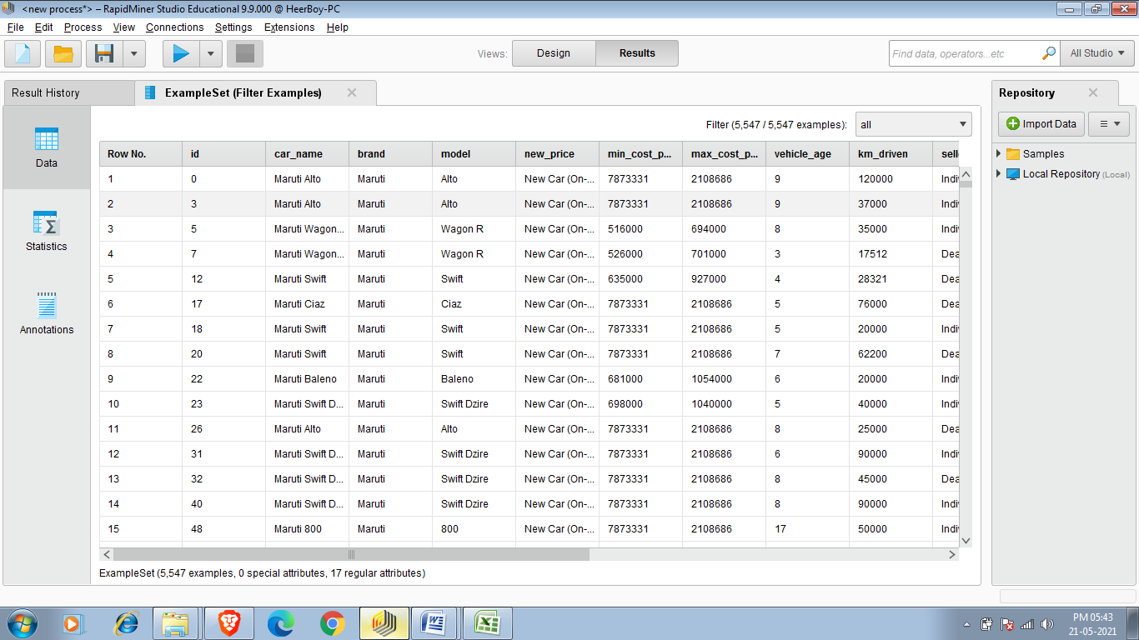

Now my requirement is that i want to see those car whose age not more than 4 year and fuel type is diesel and seating capacity is 7 and have atleast 18 mileage so we use 4 filter example which will help to get our desired result because i want to self analyse the price of car as per my requirement.

Filter 1:-

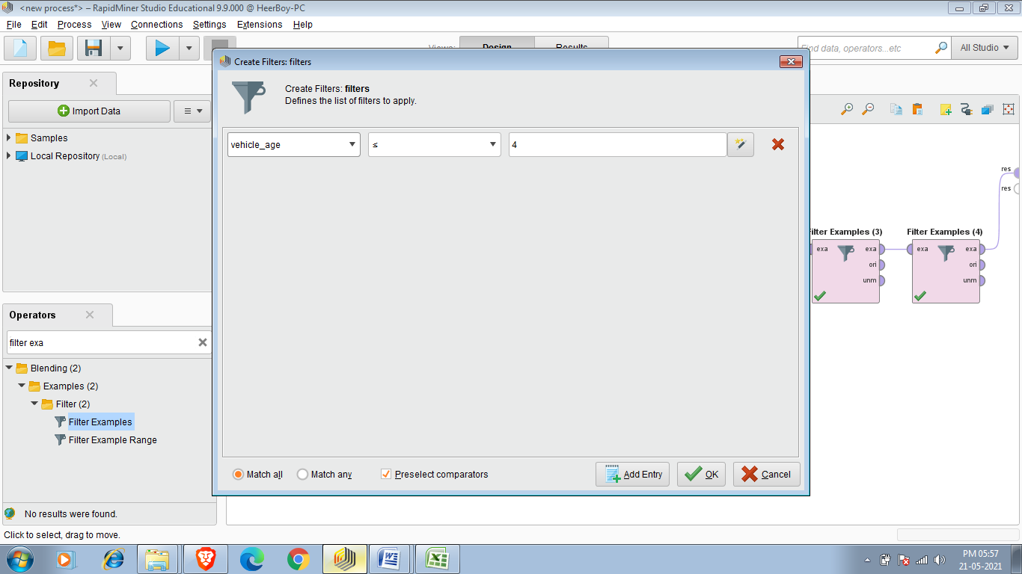

Filter 2:-

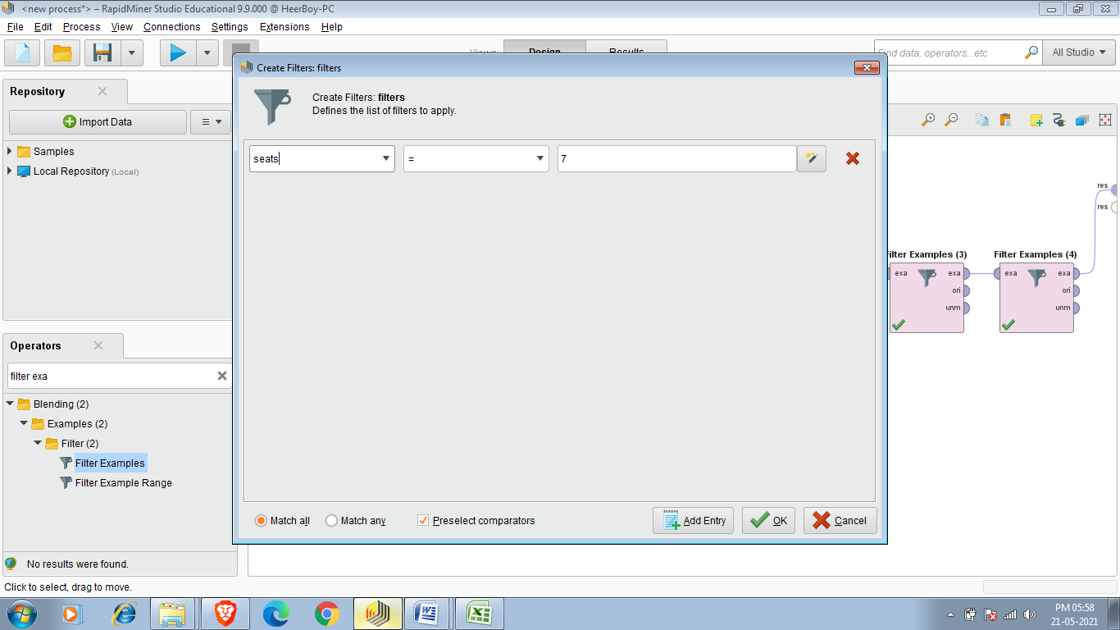

Filter 3:-

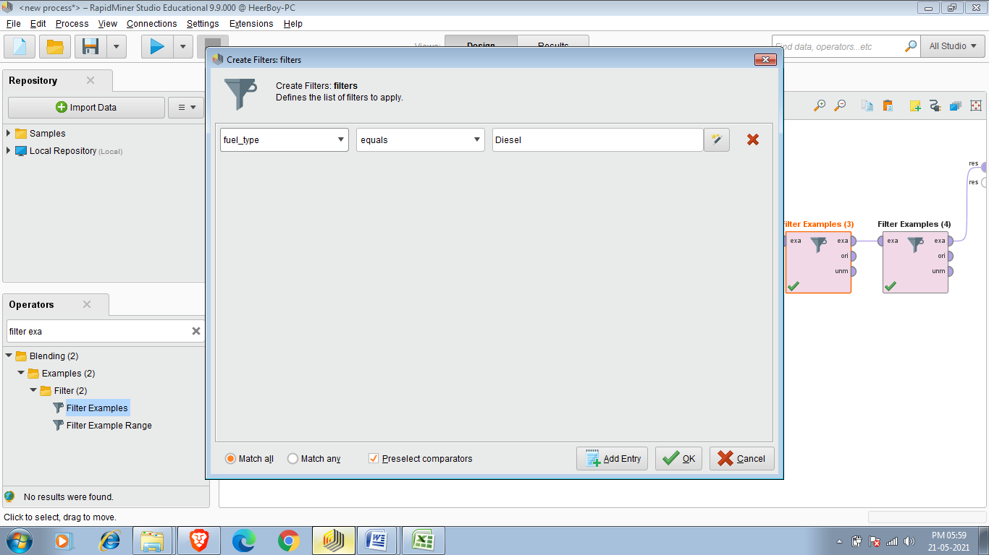

Filter 4:-

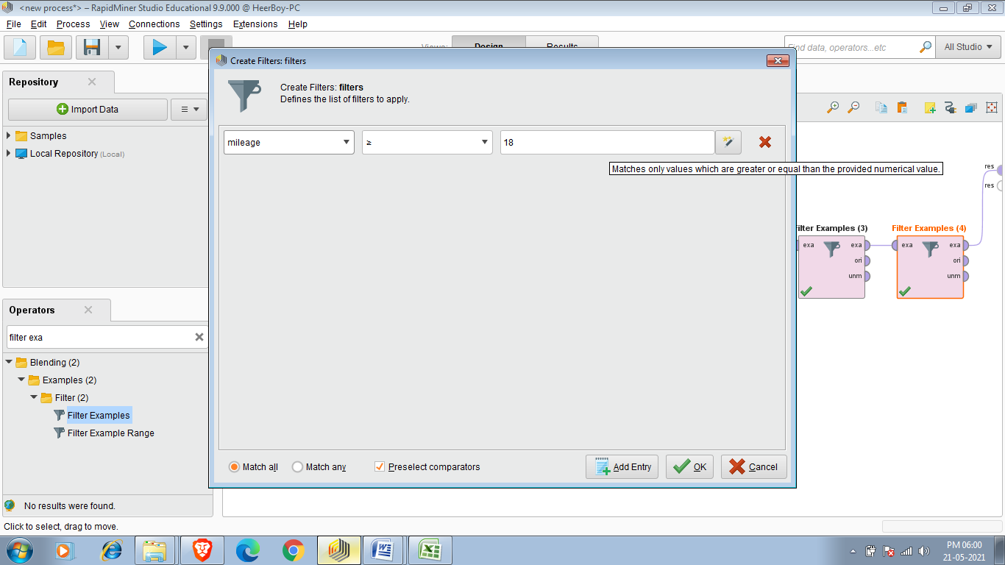

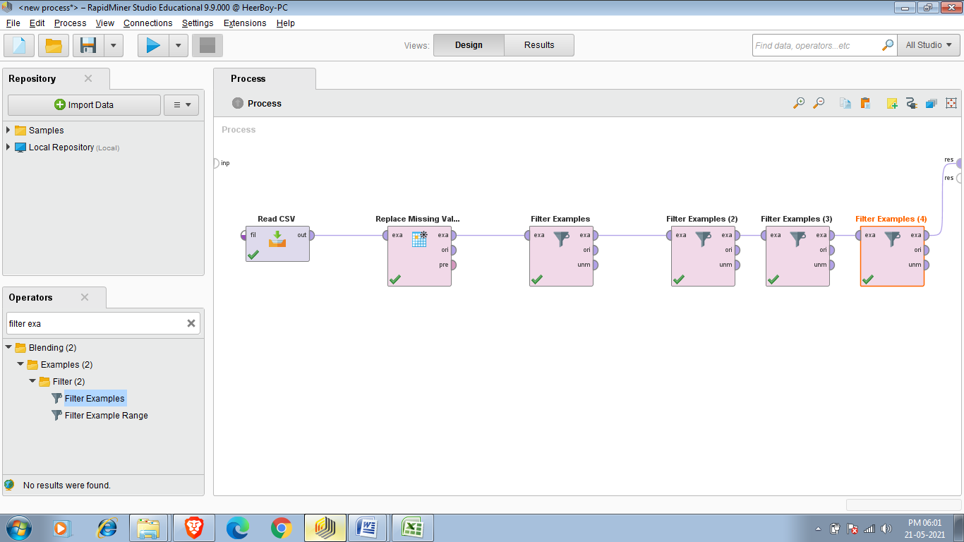

Final Result:-

Final result contains data of 137 old cars from the dataset of 19544 old used cars of cardekho so 137 cars satisfy our all requirements.

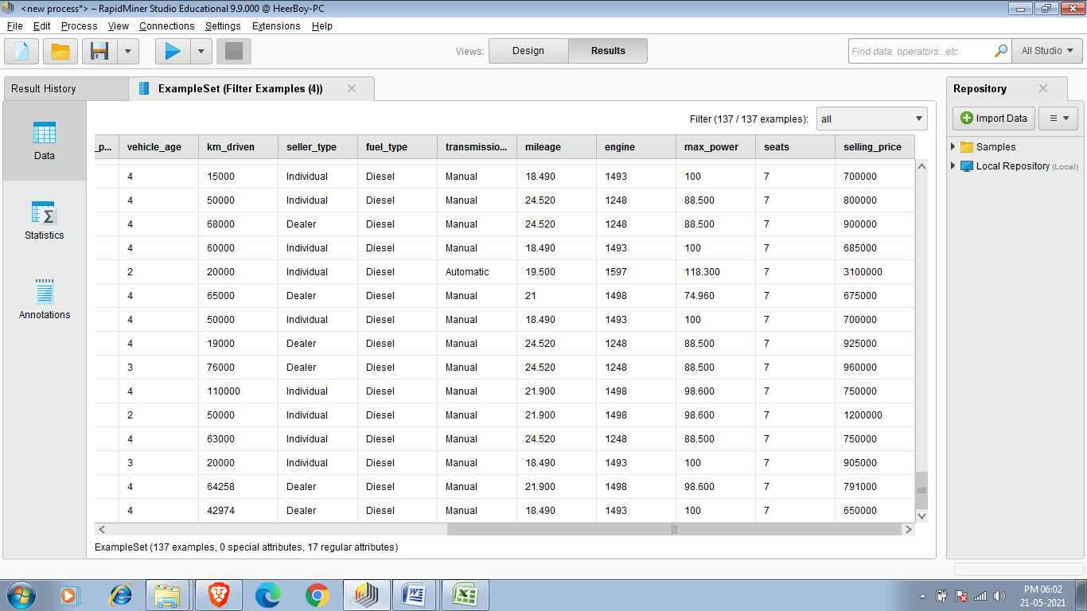

Another operator we can use after Filter Examples .so sample basically create sample set of data which we get after applying Filter Examples and default size of set created by sample operator is 100.

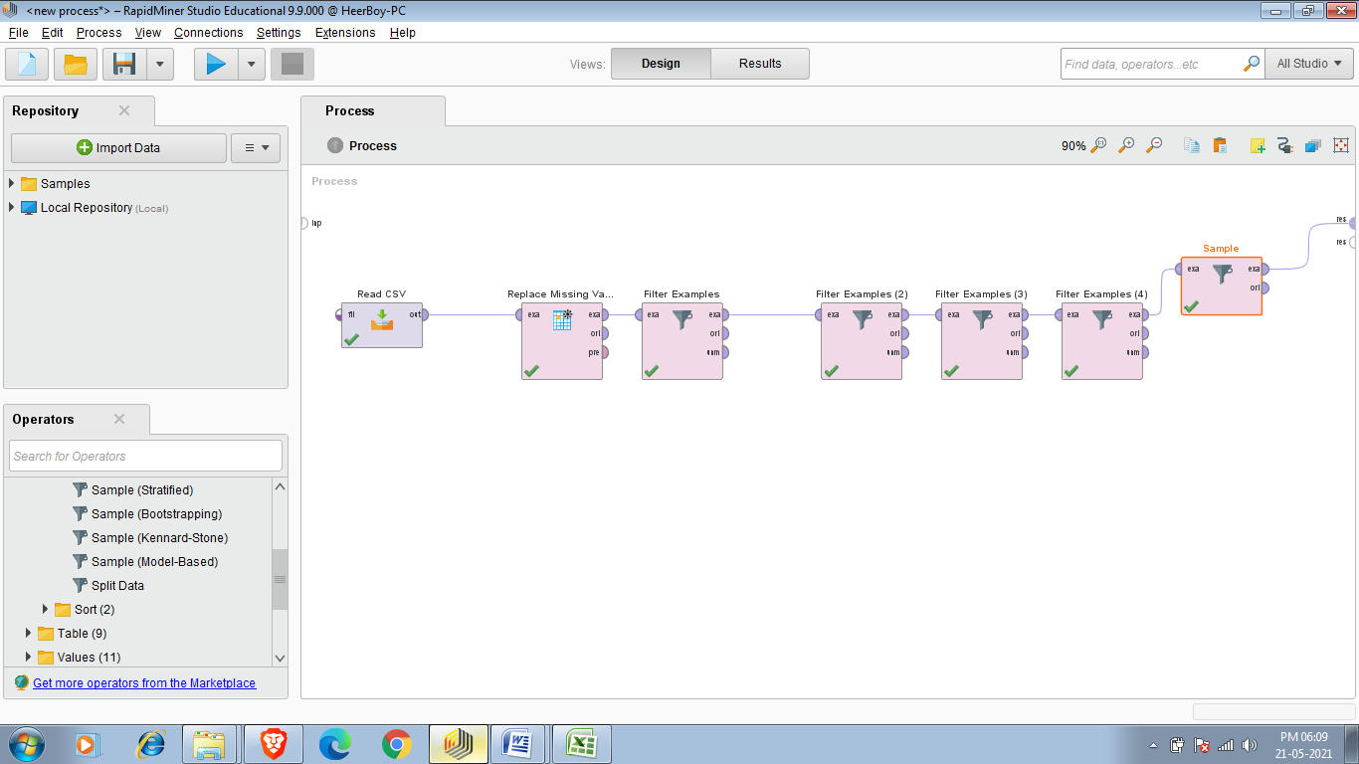

Final Result after applying sample operator:-

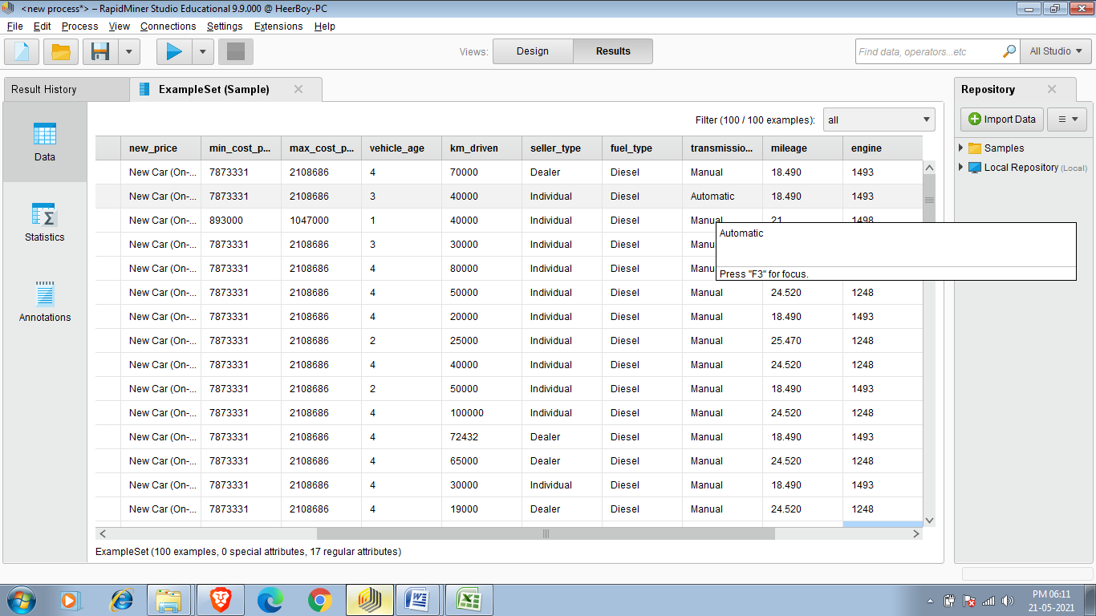

Task 4:- Applying Shuffle operator

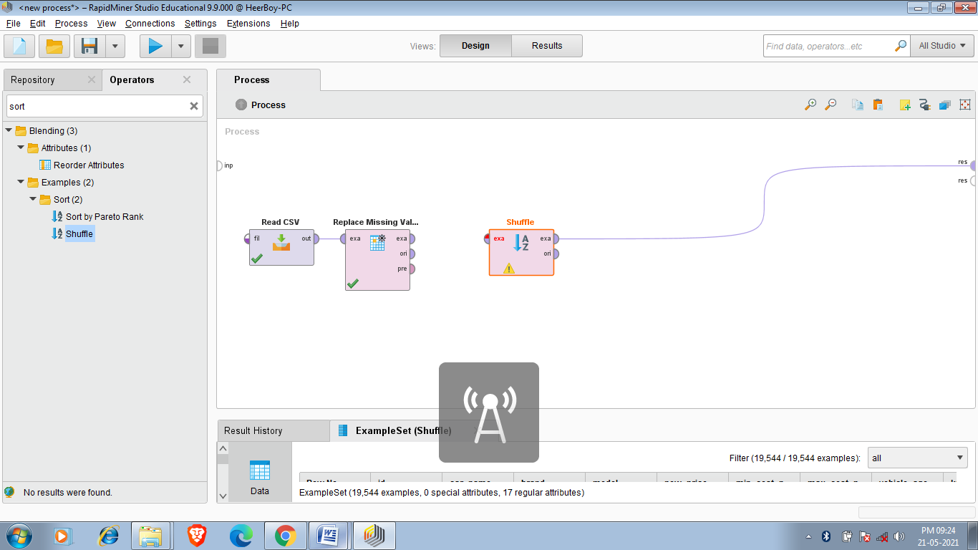  
 Shuffle :-

This operator creates a new, shuffled ExampleSet from the given ExampleSet by making a new copy of the given ExampleSet in the main memory. Description The Shuffle operator creates a new, shuffled ExampleSet by making a new copy of the given ExampleSet in the main memory. Please note that the system may run out of memory, if the ExampleSet is too large. The local random seed parameter can be used for randomizing the shuffling process.

Lets apply shuffle on small data set (All_cars_dataset.csv)

Dataset before shuff le

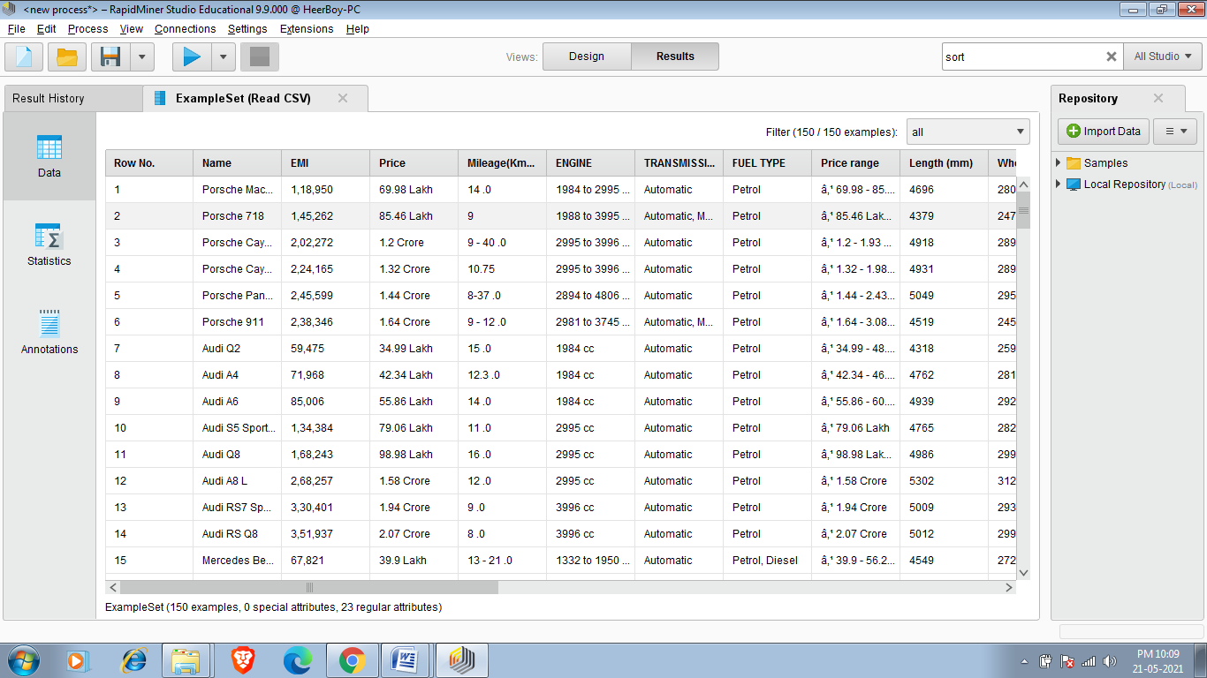

PROCESS(APPLYING SHUFFLE OPERATOR):-

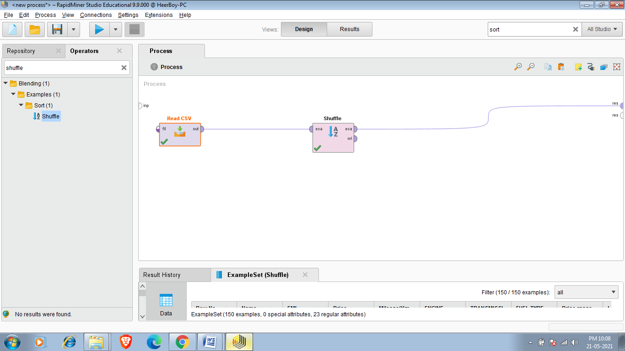Result after applying Shuffle operator:-

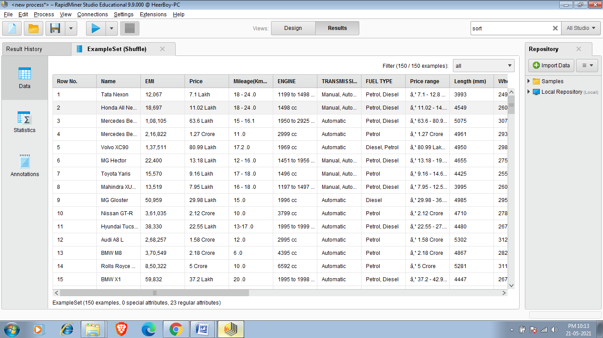

The new shuffled set is in result.

**Sort**

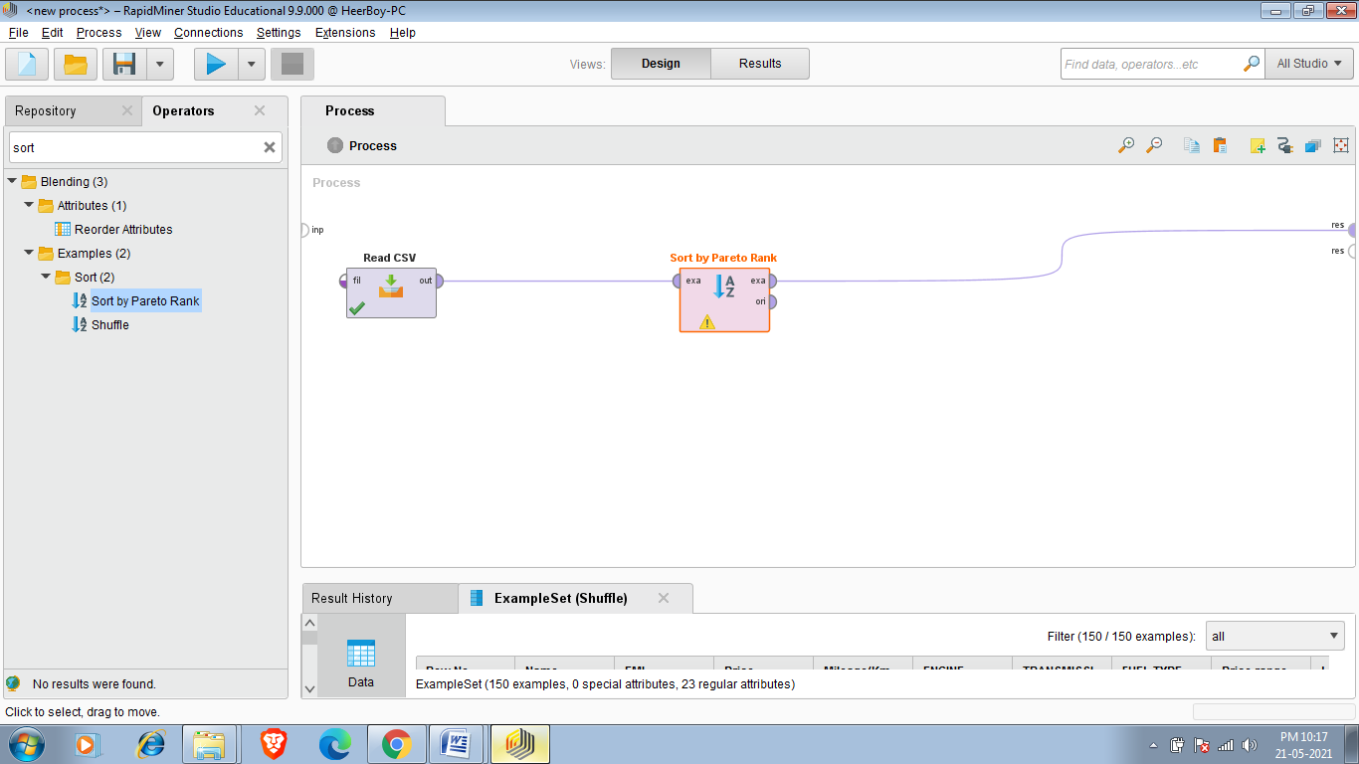

This operator sorts the input data set in ascending or descending order according to several attributes.

**Description**

This operator sorts the data set provided at the input port. The complete data set is sorted according to a single or more attributes. The attributes to sort by are specified using the sort by parameter. For each attribute, sorting is done in ascending or descending order, depending on the setting of the sorting order parameter. The resulting data set is sorted by the first attribute, then subsets of the same value in the first attribute are sorted by the second attribute etc.

TO PERFORM THIS TASK I AM USING GENERAL ESPORTS DATA SET.

The general esports dataset contains data of 521 Esports Games and this data has Game,Release Date ,Genre ,Total Earning ,Online Earning ,Total Players and Total Tournament Attributes now I am sorting this data set on the basis of two attributes Total Earning and Online Earning where Total Earning is Primary Attribute And Onine Earning is Secondary Attribute.

Initial Dataset:-

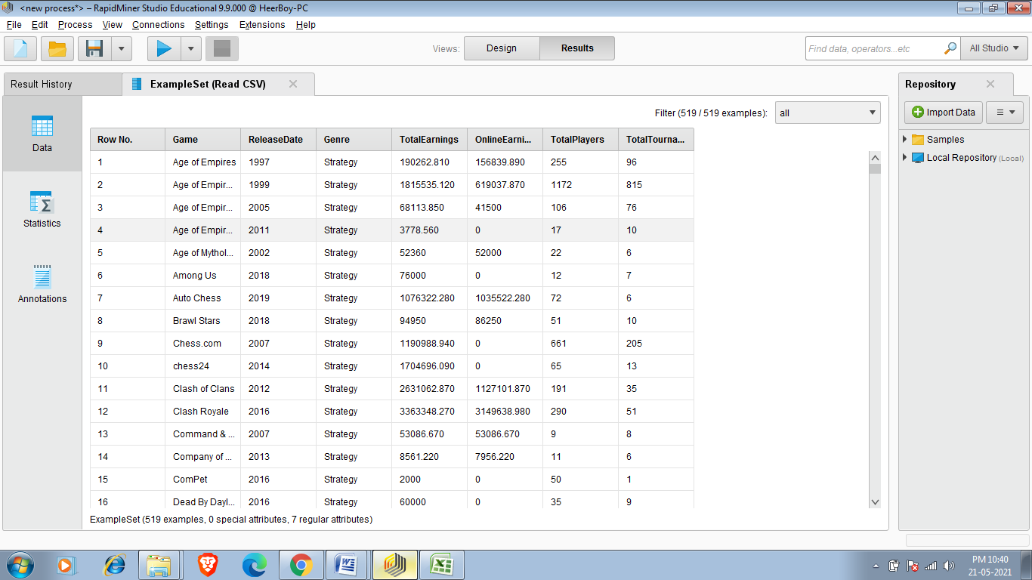

Applying Sort Operator on the basis of Two attributes TotalEarnings and OnlineEarnings

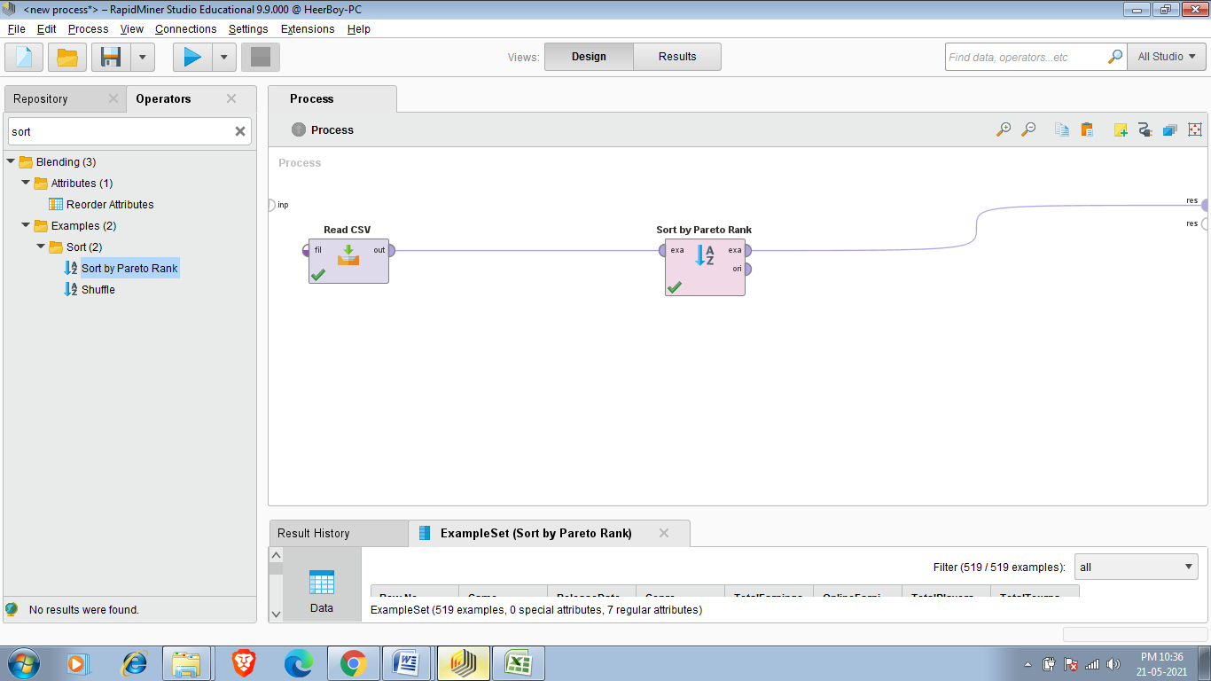

Final Dataset After Sorting:-

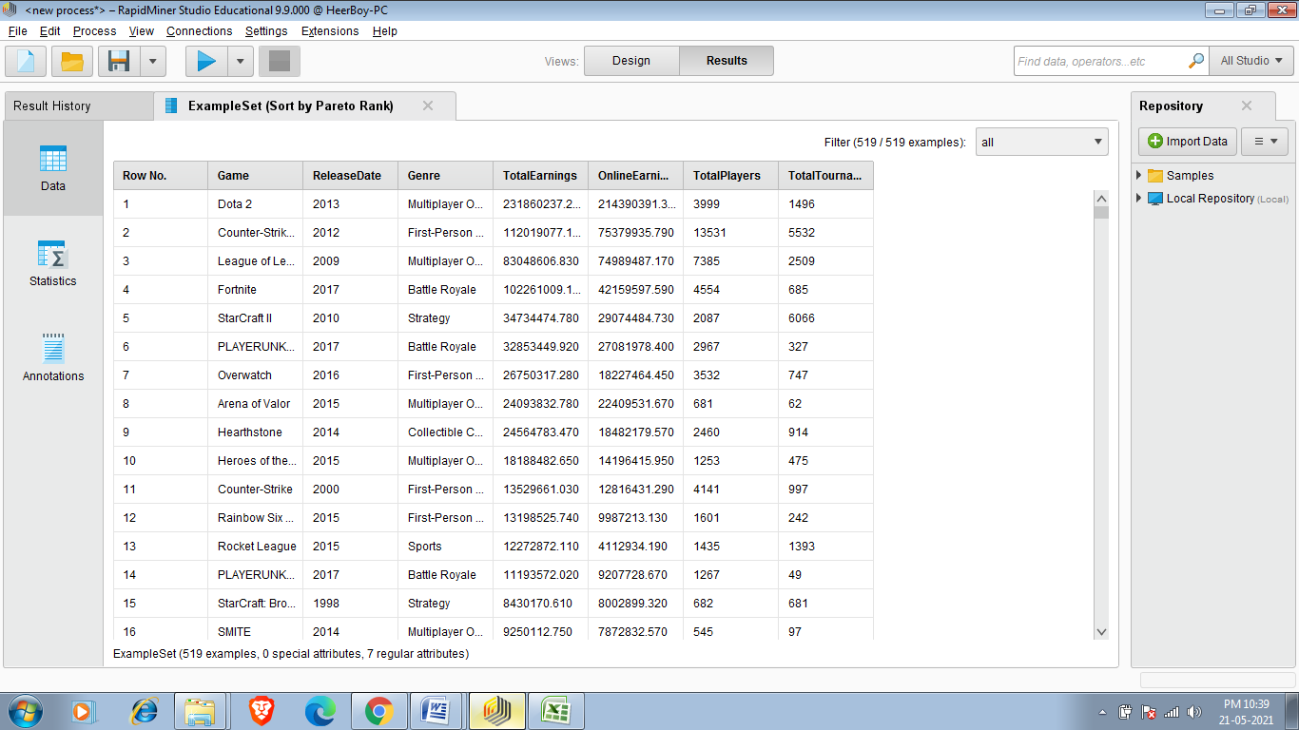

Task:-Perform Grouping

We use aggregate operator to perform grouping.

Aggregate

This operator performs the aggregation functions known from SQL. This operator provides a lot of functionalities in the same format as provided by the SQL aggregation functions. SQL aggregation functions and GROUP BY and HAVING clauses can be imitated using this operator. Description The Aggregate operator creates a new ExampleSet from the input ExampleSet showing the results of the selected aggregation functions. Many aggregation functions are supported including SUM, COUNT, MIN, MAX, AVERAGE and many other similar functions known from SQL. The functionality of the GROUP BY clause of SQL can be imitated by using the group by attributes parameter. You need to have a basic understanding of the GROUP BY clause of SQL for understanding the use of this parameter because it works exactly the same way. If you want to imitate the known HAVING clause from SQL, you can do that by applying the Filter Examples operator after the Aggregation operator. This operator imitates aggregation functions of SQL. It focuses on obtaining summary information, such as averages and counts etc. It can group examples in an ExampleSet into smaller sets and apply aggregation functions on those sets.

Now I perform aggregate function on cardekho_cleaned.csv dataset.

My requirements are i want to see average price of cars and car fuel type shold be diesel ,mileage should be greater or equal to 18 ,should have 7 or more seating capacity and car should not be older than 3 years .

So here is the solution

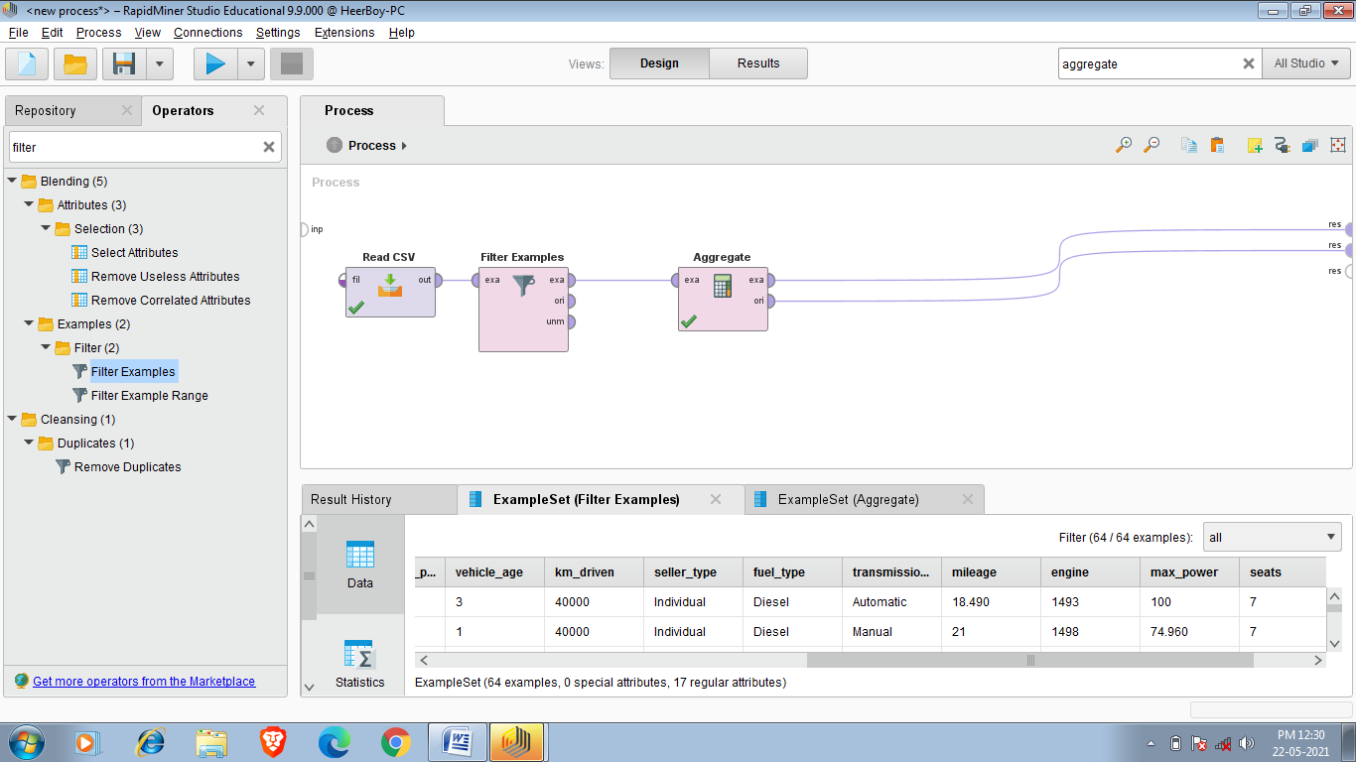

All Filters:-

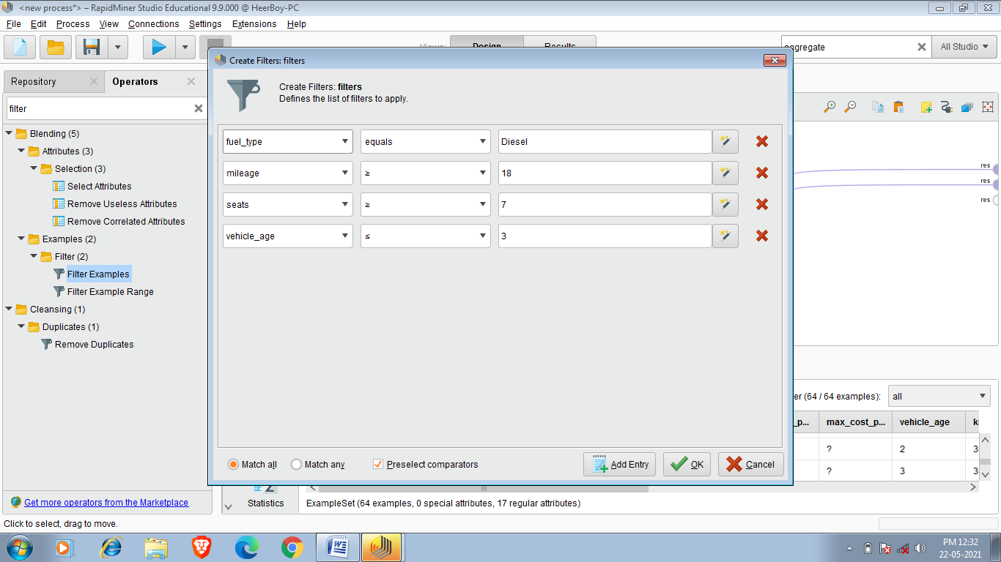

Aggregate Function:-

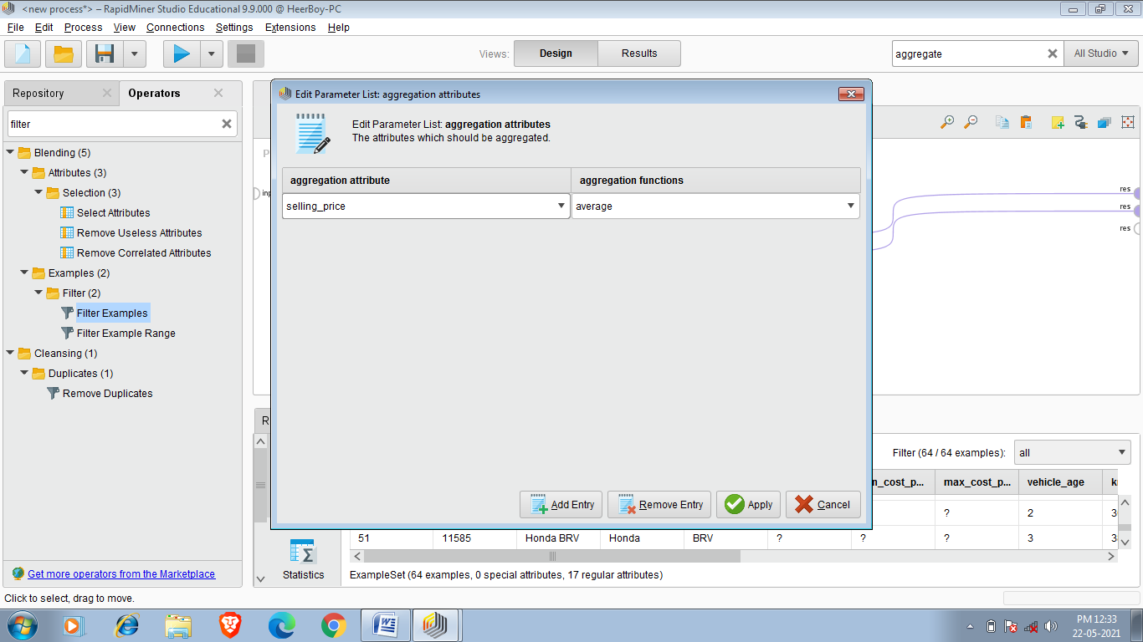

Final Result:-

So there is 64 cars out of 19544 that satisfy our requirements and average price of car that we require is 1049265.625.

And final required dataset is below:-

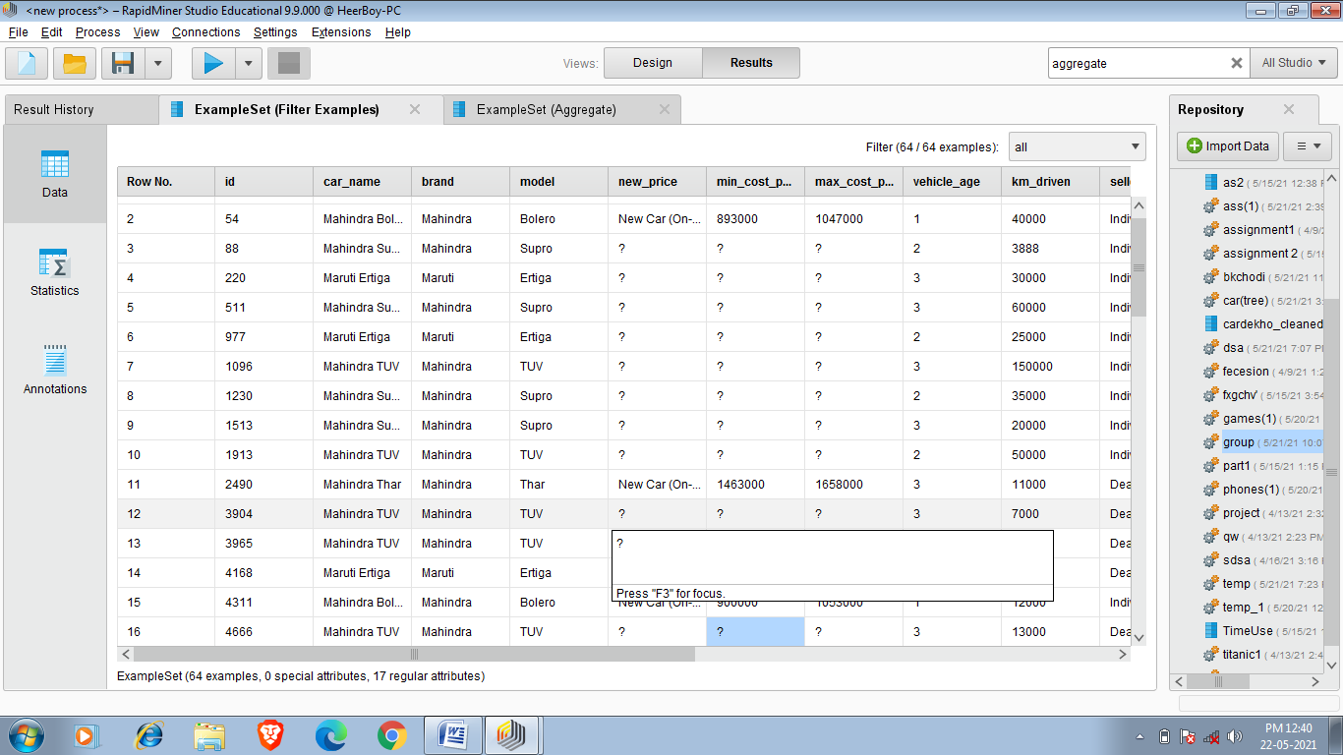

Another Example:-

Now i want to buy car and my requirements are that cars transmission_type should be automatic(because i love automatic cars),engine should be powerful (engine>=1200),mileage should be greater than 22(mileage>=22) because petrol or diesel prize is high and i prefer car with more mileage,and my last requirement is vehicle should not have to be more than 4 years old (vehicle_age<=4).so i want to know min and average price of my required car .

So first of all i have to select my reguired set which is caardekho_cleeaned.csv and after choosing that i have toapply all filters as per our requiremements as shown below.

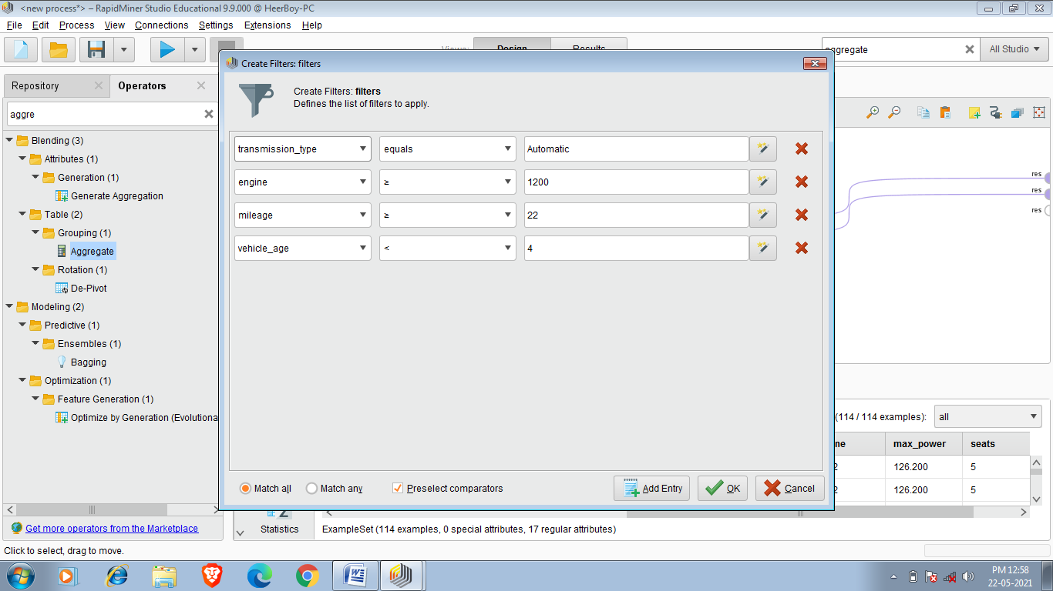

After Applying filter i have to apply aggregate function.since i want to know average selling_price and minimum selling_price of my required car so i perform these tasks one by one.

Minimum Selling_price

So 114 cars satisfy our requirements out of 19544 cars and minimum selling price of required car is 495000.

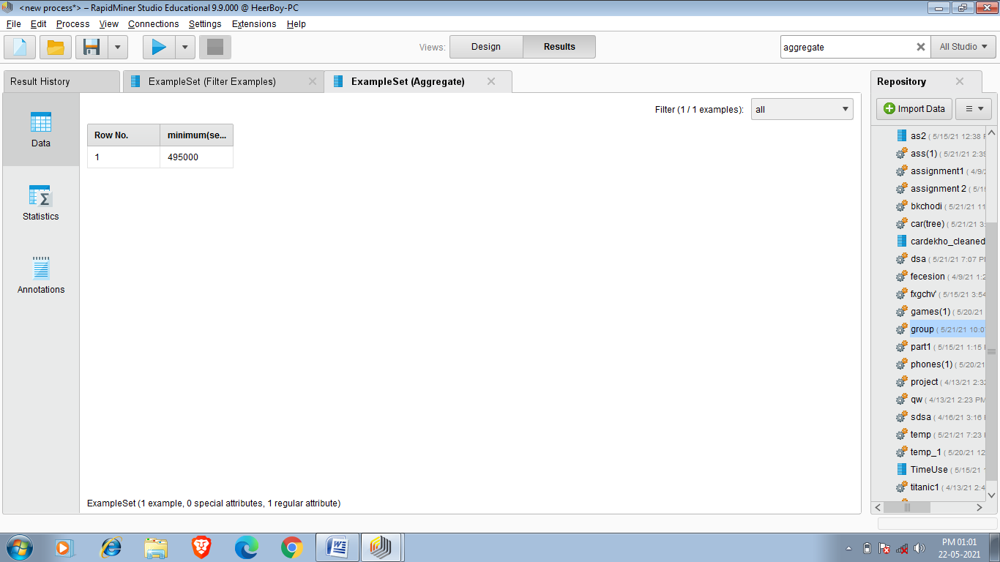

Final Set:-

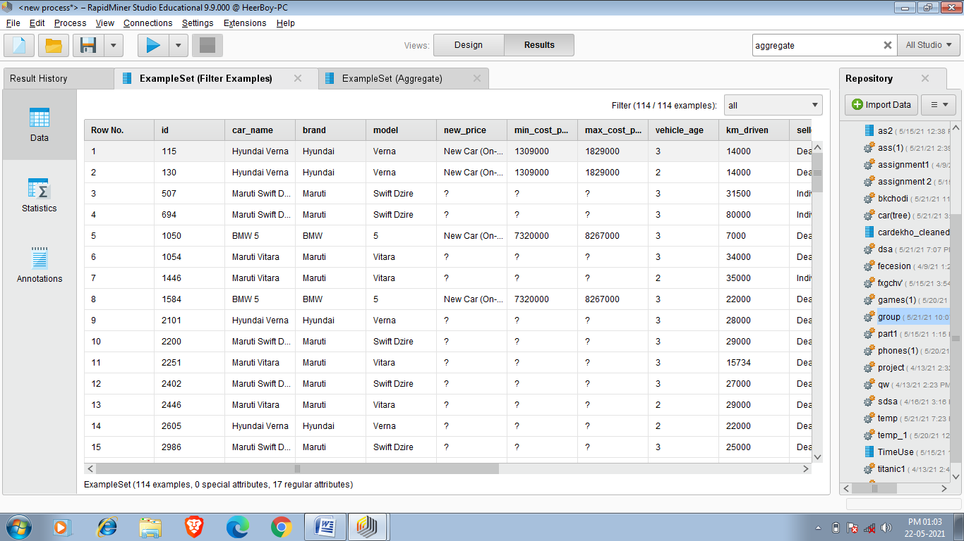

Average Selling_price:-

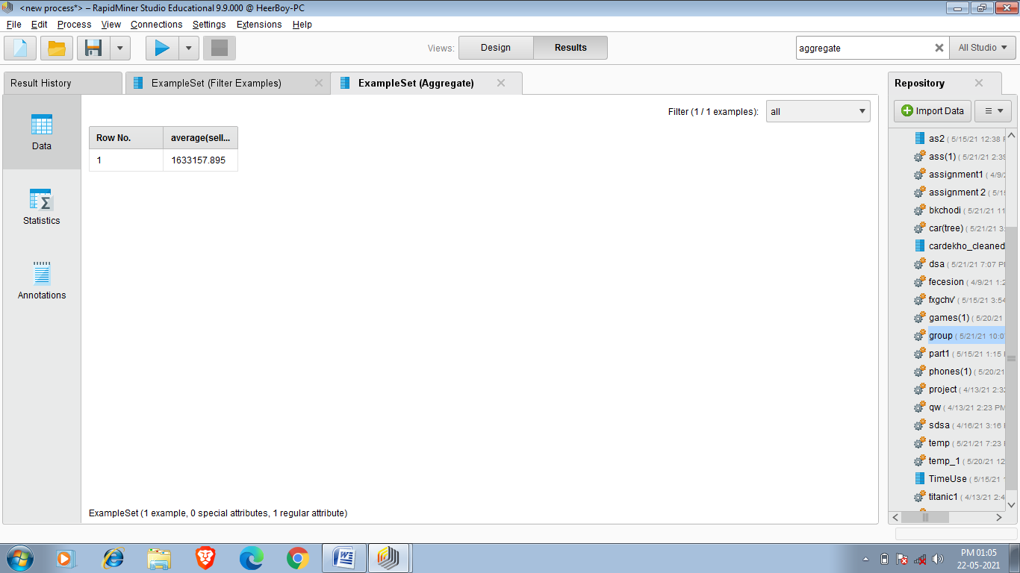

So average selling price of car that i require is 1633157.895

Task : Decision Tree

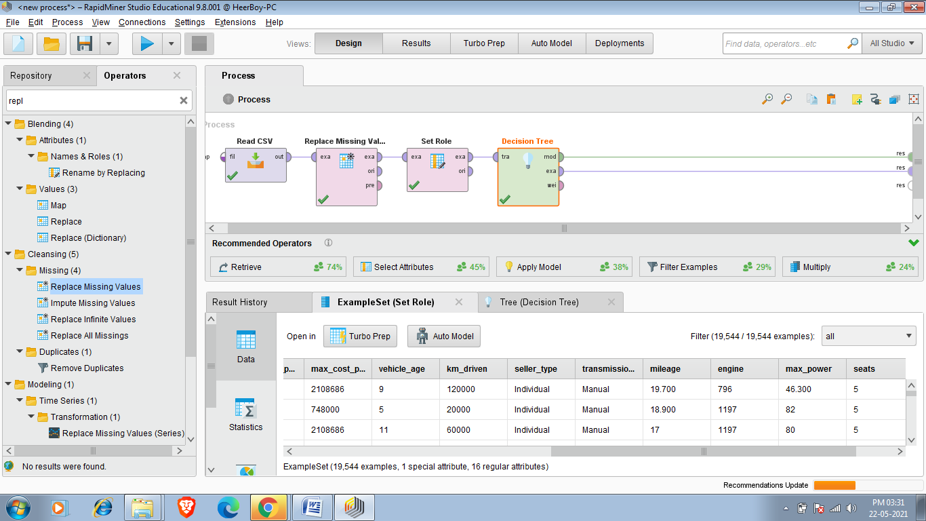

This Operator generates a decision tree model, which can be used for classification and regression.

Description

A decision tree is a tree like collection of nodes intended to create a decision on values affiliation to a class or an estimate of a numerical target value. Each node represents a splitting rule for one specific Attribute. For classification this rule separates values belonging to different classes, for regression it separates them in order to reduce the error in an optimal way for the selected parameter *criterion*.

The building of new nodes is repeated until the stopping criteria are met. A prediction for the class label Attribute is determined depending on the majority of Examples which reached this leaf during generation, while an estimation for a numerical value is obtained by averaging the values in a leaf.

To perform this i am using cardekho_cleaned.csv and i am creating decision tree which tells fuel type of car according to different aspects .



Task:-Decision Tree

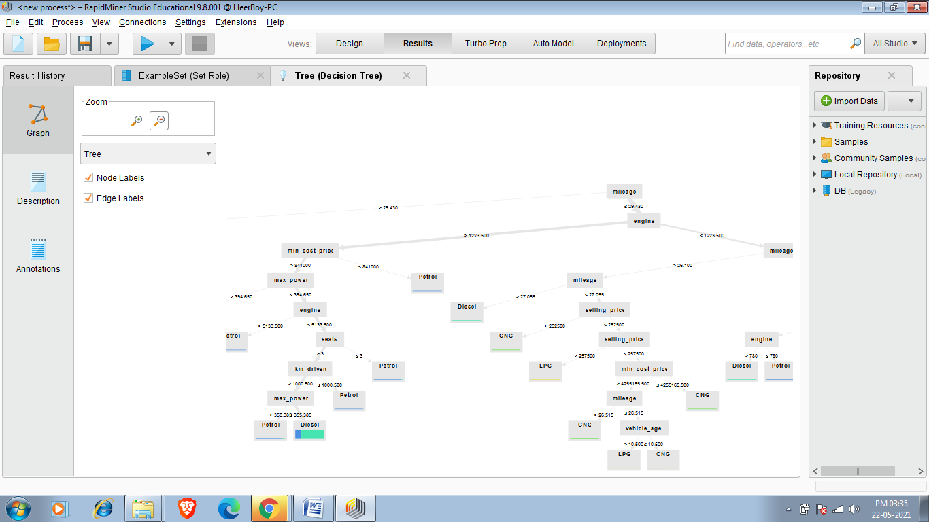

This defines fuel type of car according to mileage, min_cost_price , max_power ,seats,selling_price etc,

Now i am generating decision tree taking transmission_type as label so it will create decision tree which will tell transmission type of car on the basis of different aspects.

So resulted decision tree is:- 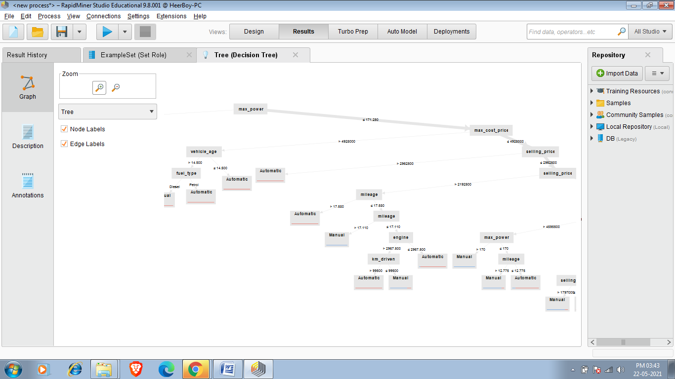

Now i am using All_cars_dataset.csv .this data set contains data of 150 new cars.And i want to know about seating capacity .So taking seating capacity as a label it will generate decision tree of car that tell about seating capacity according to various aspects.

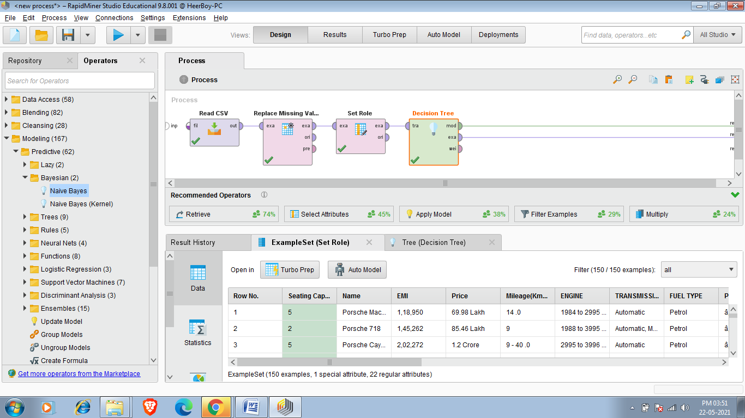

Decesion Tree:-

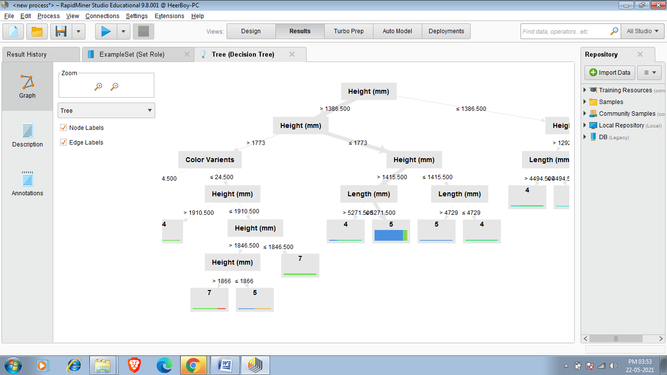

This decision tree defines Seating capacity of car according to height ,width and color variants.

Task:-Correlation

Correlation is a statistical measure of how strong the relationship are between attributes in a dataset .So we use Correlation Matrix operator to generate correlation between attributes.It is simply a measure of the strength of the relationship between each possible set of attributes in data set.

Correlation coefficients tell us something about the relationship between attributes, and this is helpful, but they also tell us something about the strength of the correlation. All correlations will fall between 0 and 1 or 0 and -1. The closer a correlation coefficient is to 1 or to -1, the stronger it is. Below Figure illustrates the correlation strength along the continuum from -1 to 1.

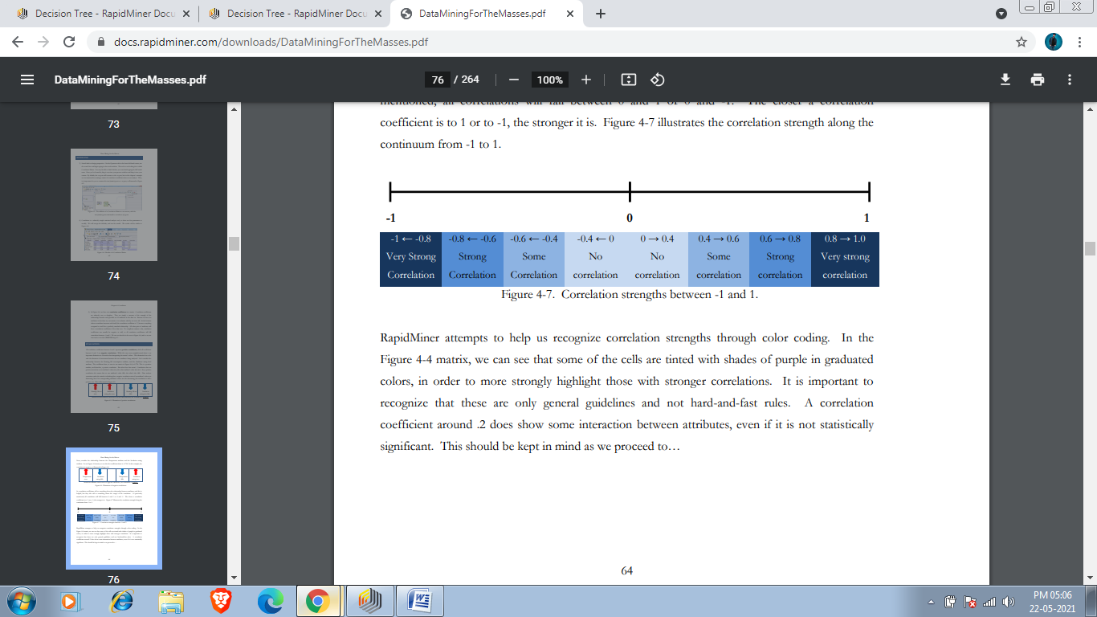

TasK:-Finding Correlation between different attributes of cardekho_clean.csv

To perform this task first we have add read csv operator as we done in our previous tasks .Then we have to add dataset.

Required data set

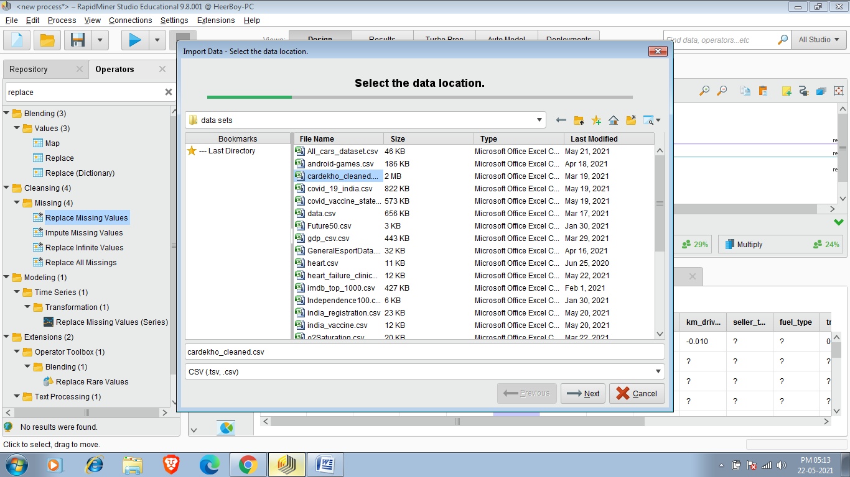

Now to perform Correlation(How much attributes of dataset related to each other) we use Correlation Matrix.just open operator seach panel and search correlation matrix.

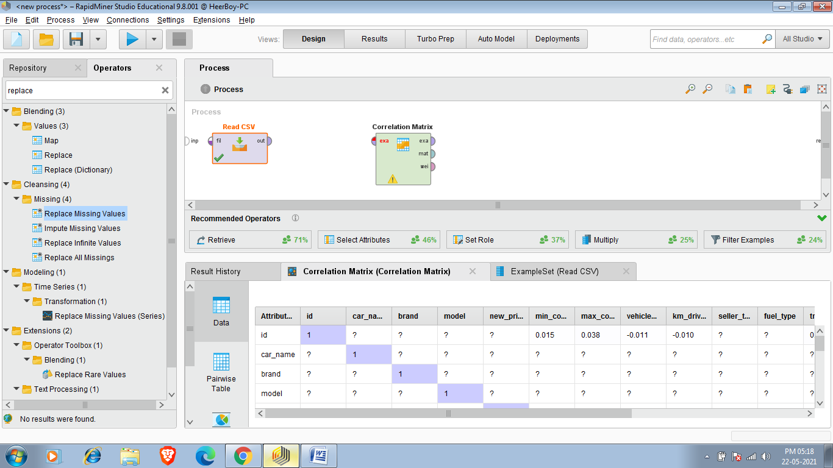

Now Connect Out of Read CSV to exa of Correlation Matrix.And then connect exa(example dataset) ,mat of correlation Matrix to res and run the process.

Result of Correlation Matrix:-

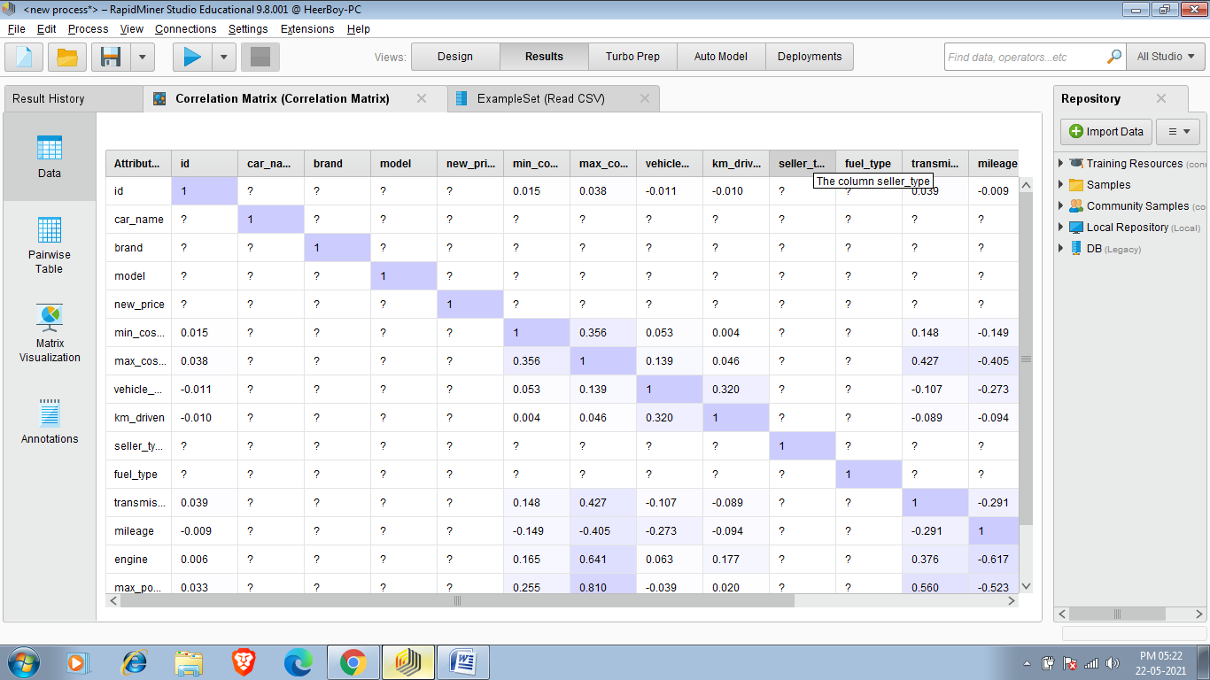

Applying correlation matrix in world-happiness-report-2021.csv dataset (my downloaded dataset):-  
Result of Correlation Matrix:-

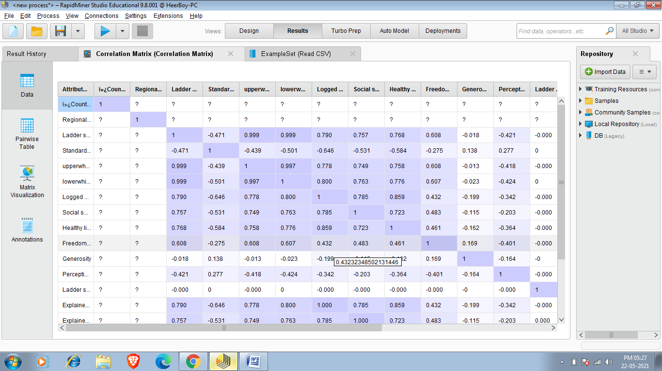

Task: Association Rules

Association rules are a data mining methodology that seeks to find frequent connections between attributes in a data set. Association rules are very common when doing shopping basket analysis. Marketers and vendors in many sectors use this data mining approach to try to find which products are most frequently purchased together. If you have ever purchased items on an e-Commerce retail site like Amazon.com, you have probably seen the fruits of association rule data mining. These are most commonly found in the recommendations sections of such web sites.

An example of an association rule would be "If a customer buys eggs, he is 80% likely to also purchase milk." An association rule has two parts, an antecedent (if) and a consequent (then). An antecedent is an item (or itemset) found in the data. A consequent is an item (or itemset) that is found in combination with the antecedent.

when you search for a smartphone, recommendations for screen protectors, protective cases, and other accessories such as charging cords or data cables are often recommended to you. The items being recommended are identified by mining for items that previous customers bought in conjunction with the item you search for.

In other words, those items are found to be associated with the item you are looking for, and that association is so frequent in the web site’s data set, that the association might be considered a rule.

Association rules are most common in shopping basket analysis, this modeling technique can be applied to a broad range of questions.

Association rules are created by analyzing data for frequent if/then patterns and using the criteria support and confidence to identify the most important relationships. Support is an indication of how frequently the items appear in the database. Confidence indicates the number of times the if/then statements have been found to be true. The frequent if/then patterns are mined using the operators like the FP-Growth operator. The Create Association Rules operator takes these frequent itemsets and generates association rules.

Such information can be used as the basis for decisions about marketing activities such as, e.g., promotional pricing or product placements. In addition to the above example from market basket analysis association rules are employed today in many application areas including Web usage mining, intrusion detection and bioinformatics.

**Applying Association :-** So to perform Association I am chosing Grocery data that is more relevant here and after association i tells which product combos have more association.

Now I am applying these association rules on a survey data which contains data of a person and it tells have this person did this thing or not.we will find that have the person who do one task has done another specific task or not.Here support means how many times the particular statement is true and confidence means if person has done particular task then how many times he has done another task.

1.First of all we have to take our dataset and my dataset is responses(1).csv .This data hass urvey of around 3378 people and there responses have they done particular task or not.

Here is my required data set

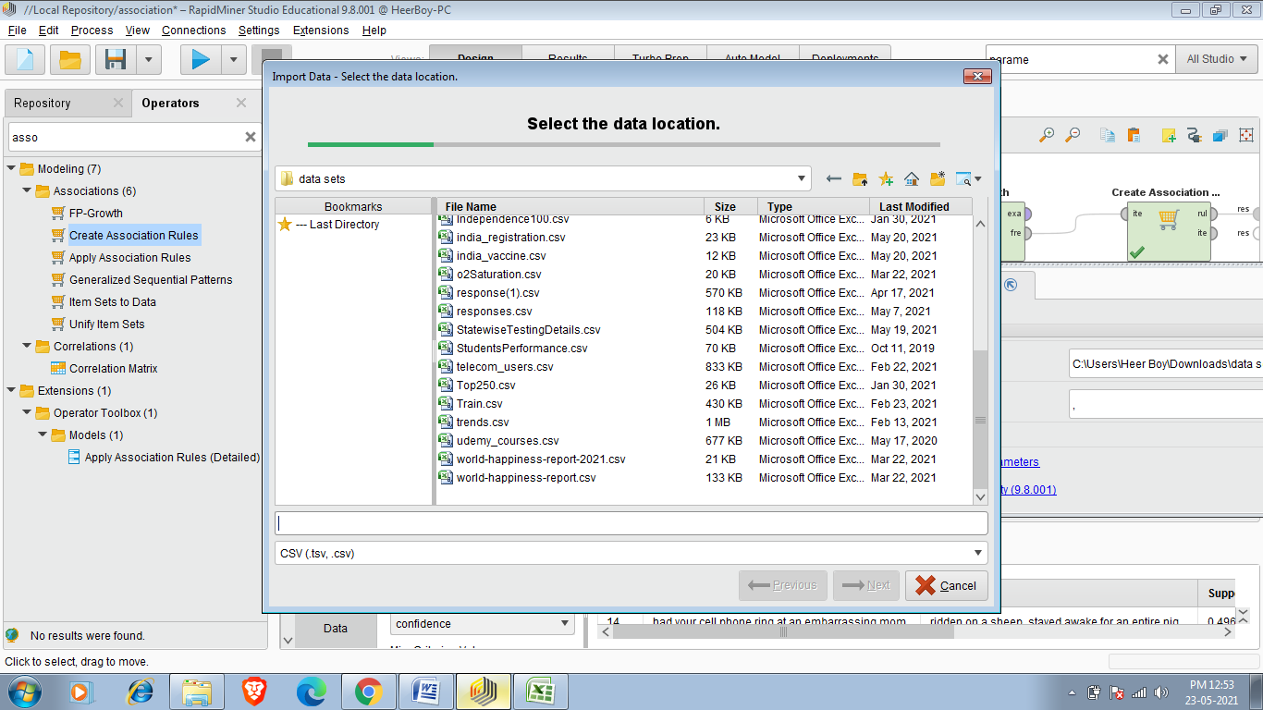

I have to select and add this data set.

2.We have to add select attributes operator and add required attributes as per reqirements.

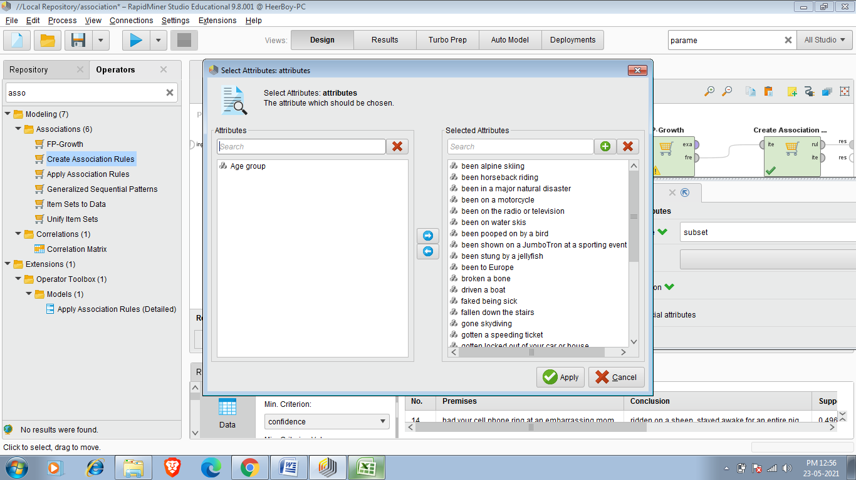

3.Since Association can’t be done on numerical data so we have to add Numerical to Binomial Operator.It converts 0,1 values to True and False.

.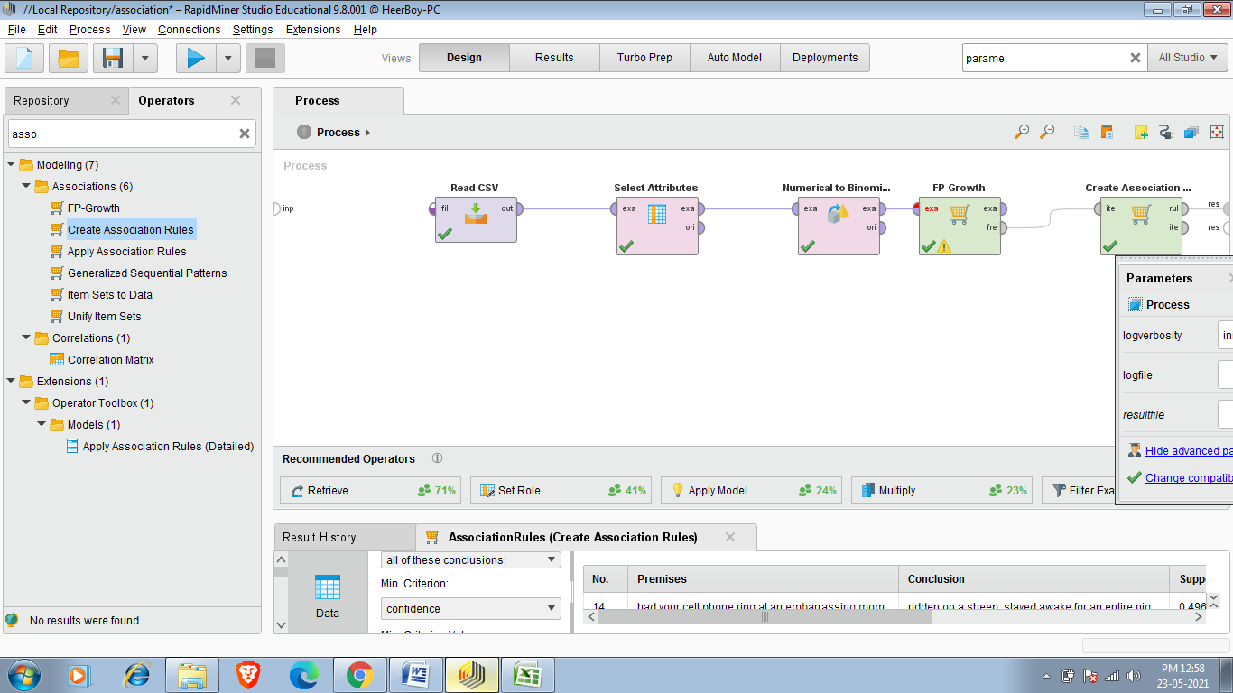

4.For Creating association First we use FP-Growth Operator.

The FP in FP-Growth stands for Frequency Pattern. Frequency pattern analysis is handy for many kinds of data mining, and is a necessary component of association rule mining. Without having frequencies of attribute combinations, we cannot determine whether any of the patterns in the data occur often enough to be considered rules.

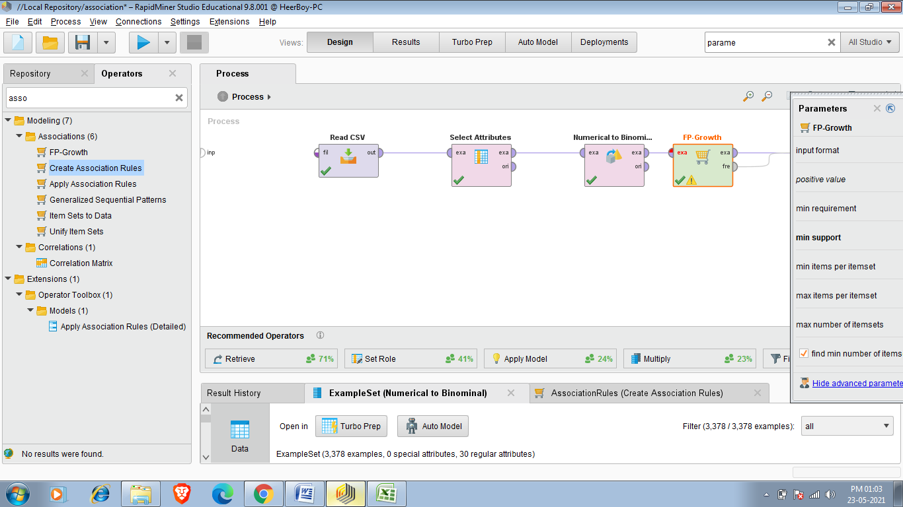

So to perform this task we require final operator named as Create Association Rules .We can search it in operator Search panel.Now you can take criterion for Association rule.I am chossing confidence here and the value of confidence i am entering is .8 which means that if person done particular task then the probability that person done another task should be more than .8(80%).

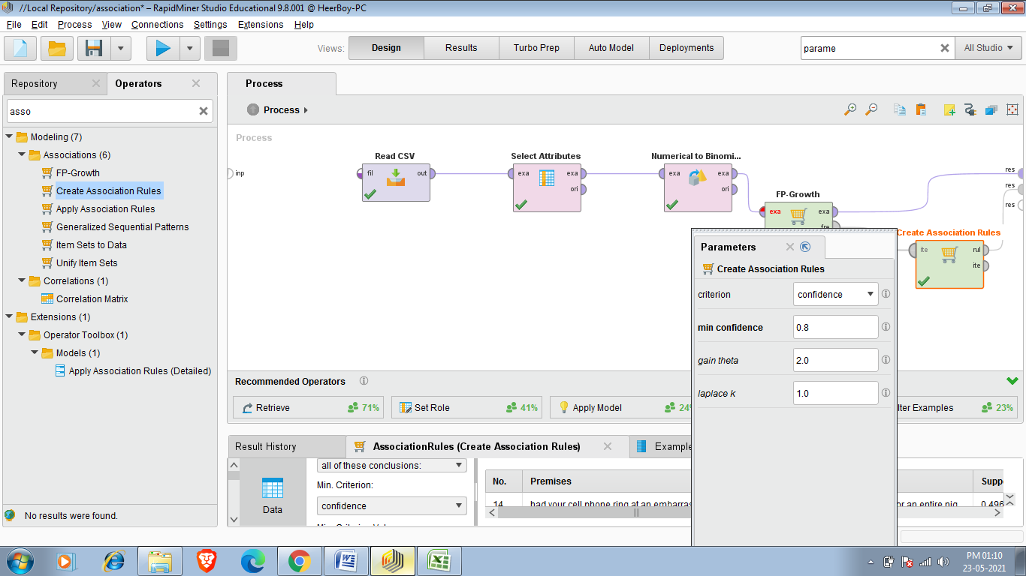

Final Result:-

So final result shows me 238 case whose confidence is more than .8(80% cha nces occurning together). 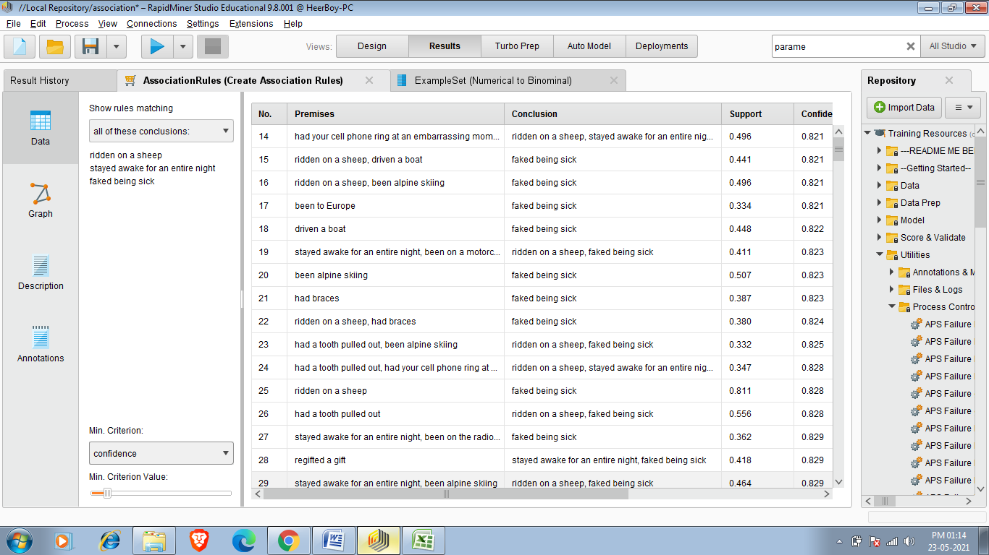

TasK:- K-MEANS CLUSTERING

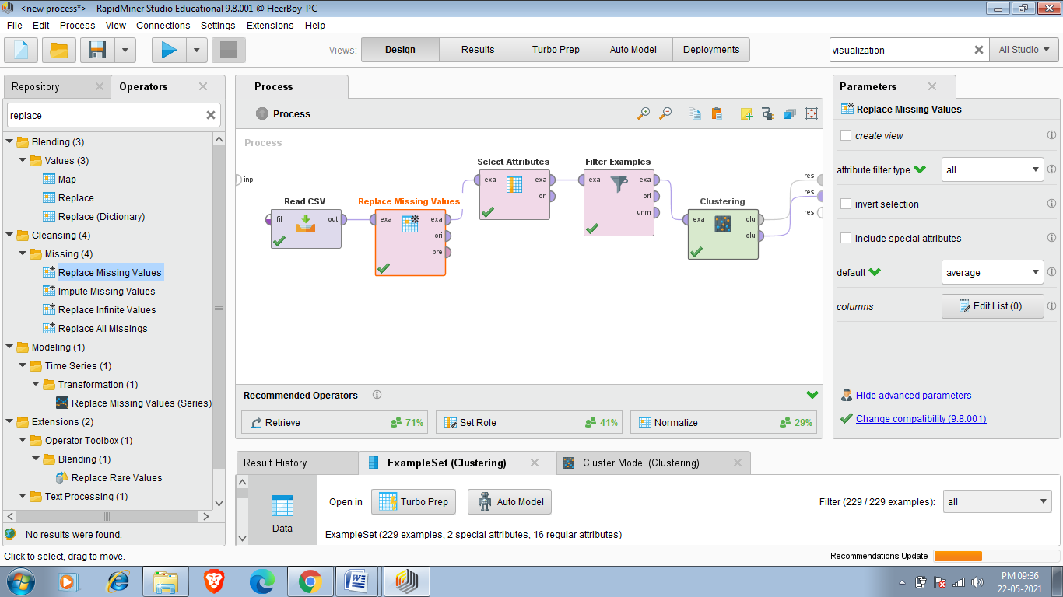

The ‘k’ in k-means clustering stands for some number of groups, or clusters. The aim of this data mining methodology is to look at each observation’s individual attribute values and compare them to the means, or in other words averages, of potential groups of other observations in order to find natural groups that are similar to one another. The k-means algorithm accomplishes this by sampling some set of observations in the data set, calculating the averages, or means, for each attribute for the observations in that sample, and then comparing the other attributes in the data set to that sample’s means. The system does this repetitively in order to ‘circle-in’ on the best matches and then to formulate groups of observations which become the clusters. As the means calculated become more and more similar, clusters are formed, and each observation whose attributes values are most like the means of a cluster become members of that cluster. Using this process, k-means clustering models can sometimes take a long time to run, especially if you indicate a large number of “max runs” through the data, or if you seek for a large number of clusters (k).

Now the task is that i want a car whose mileage should be greater than 20,vehicle age should not have to be more than 4 year,engine should be more than 1200 cc (powerful car) and transmission type should be Automatic so i apply all these filter and then form cluster to know about my required car means i have to focus at which cluster that have details about my desired car.So clustering help me to find my desire car.

**1**.First step is to add read csv operator and then add cardekho_cleaned.csv dataset as we done in our previous tasks.

**2.**After That we have to add Replace Missing Values operator because K-means clustering can’t work on missing values.

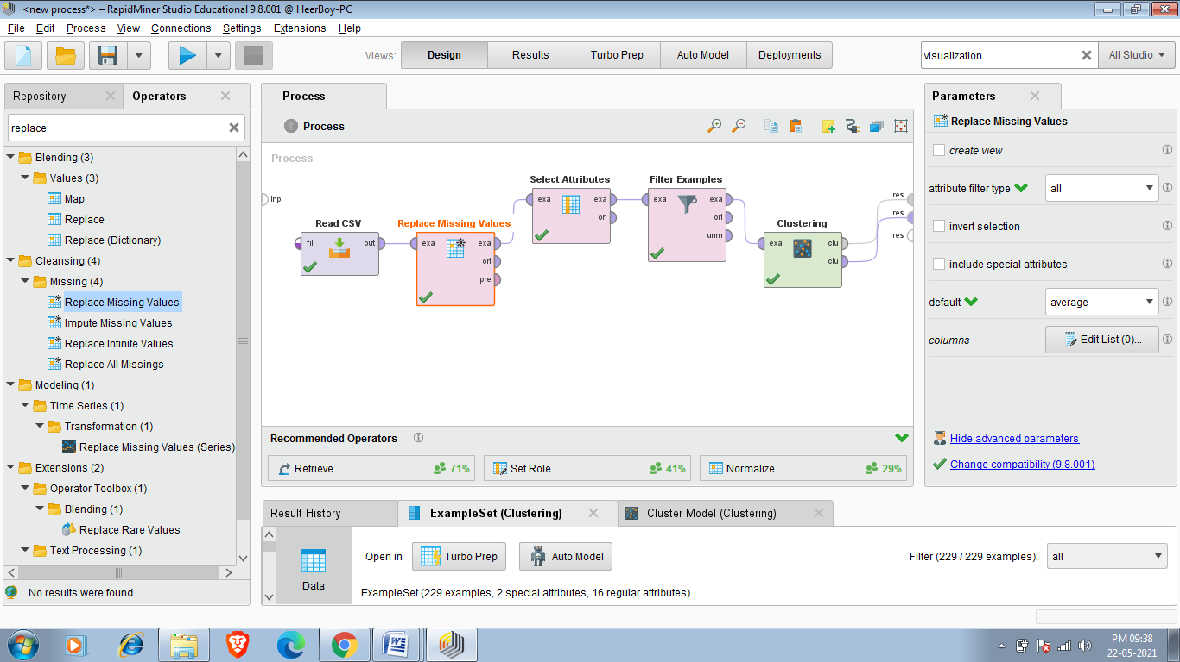

3 After adding Missing Value i can add Select attributes if i want to see only some attributes in our final result.

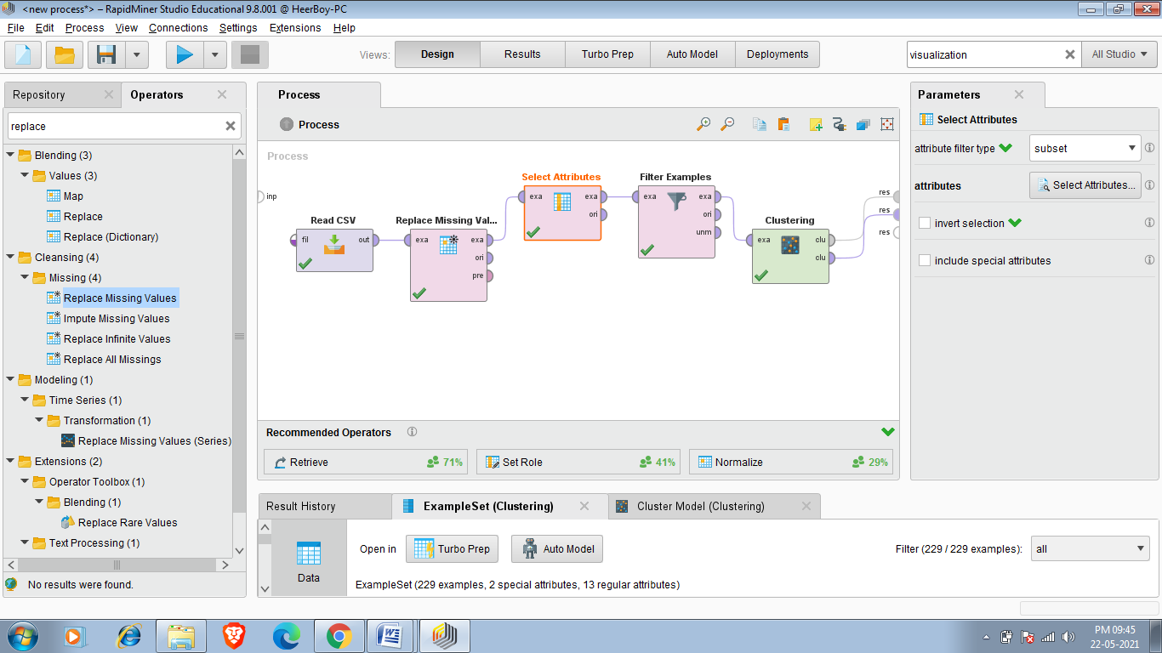

4.So after Applying select Attributes next operator am using is Filter Examples that will help me to find my desired cars ,and i apply all filters as i described before.

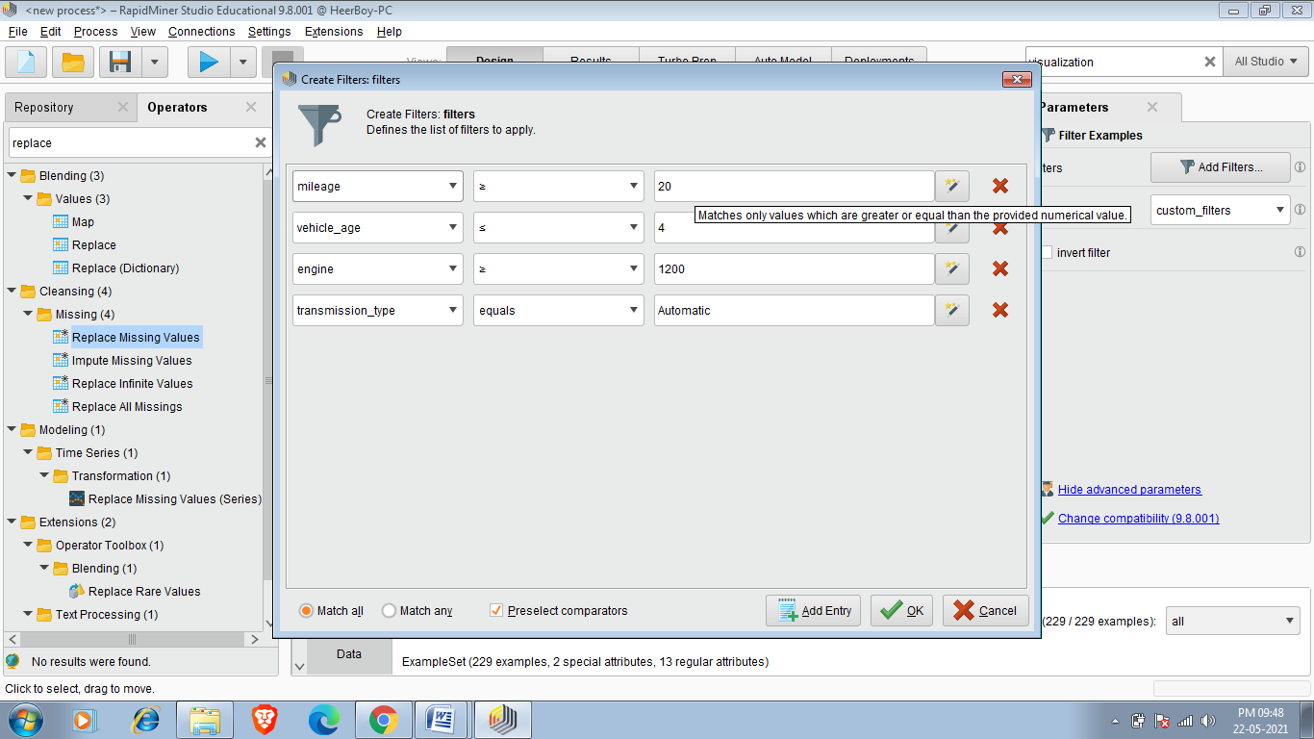

5.Now we have to make clusters and to do that we have to add k-means operator and we add it by searching k-means in operator search panel we can also make cluster of our choice by clicking on clustring operator and then filling no of clusters in k field.I am entering 5 because 5 clusters are enough to analyse my data and making more cluster may slow down my process.

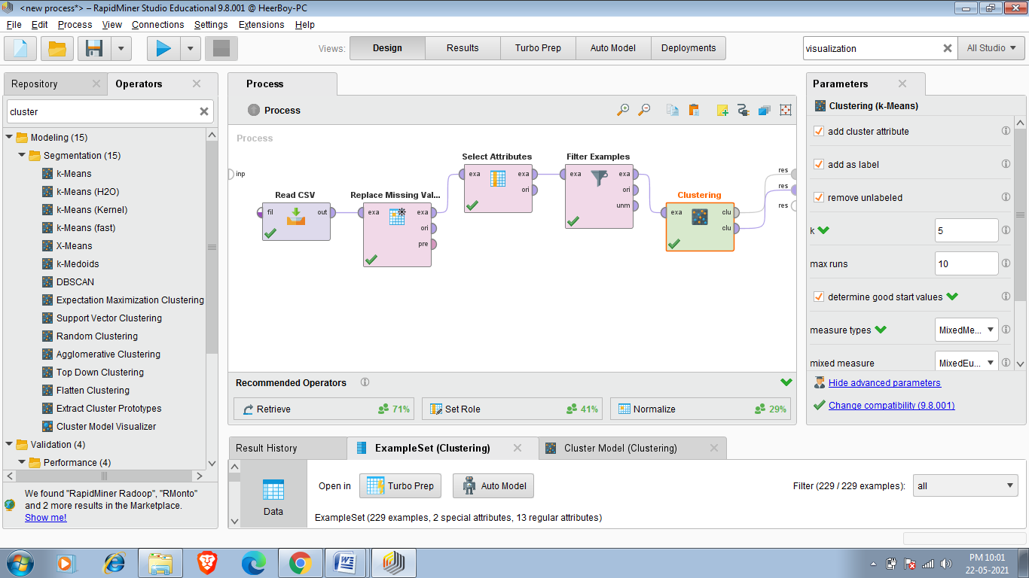

6.So in last i have to make all connections as i listed below.

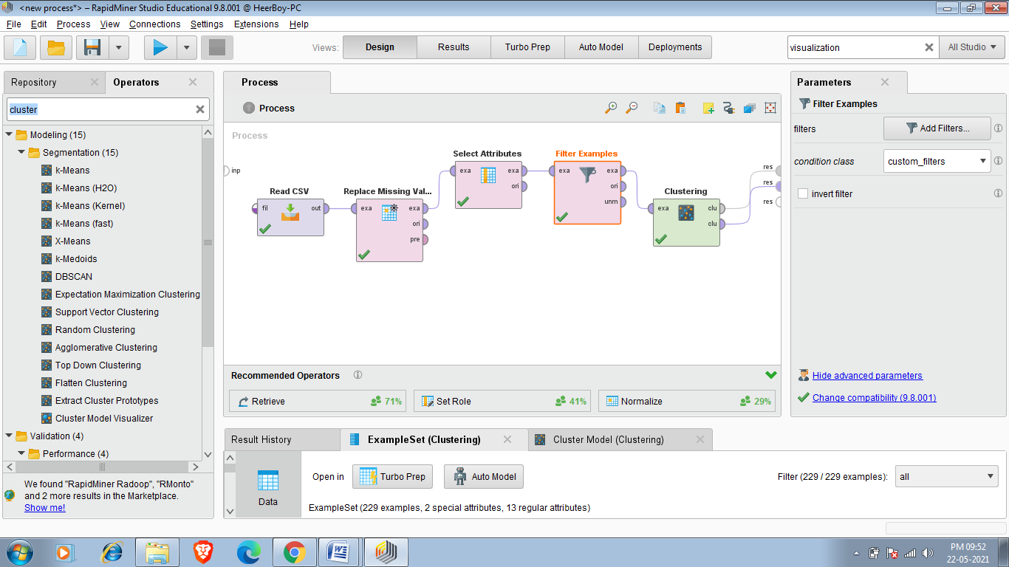

Final Result :-

So our final required dataset has 229 cars as shown below.

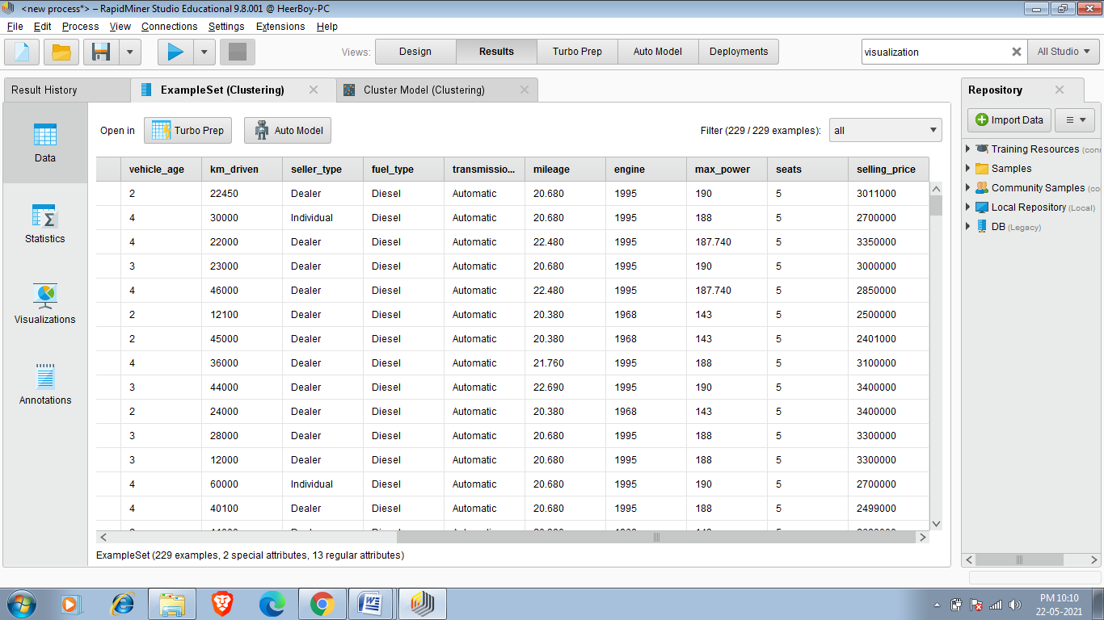

Clusters

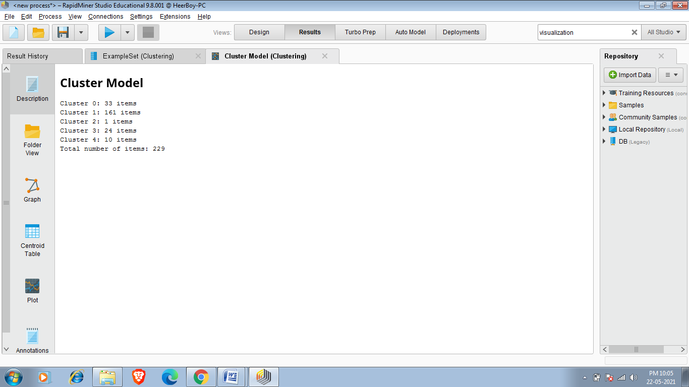

So since i require 5 cluster so Rapid miner created 5 cluster

Centroid Table:-

Centroid Table Contains mean Value of Each Selected Attribute of all cluster The Cetroid Table of My required Data set Is Given Below.

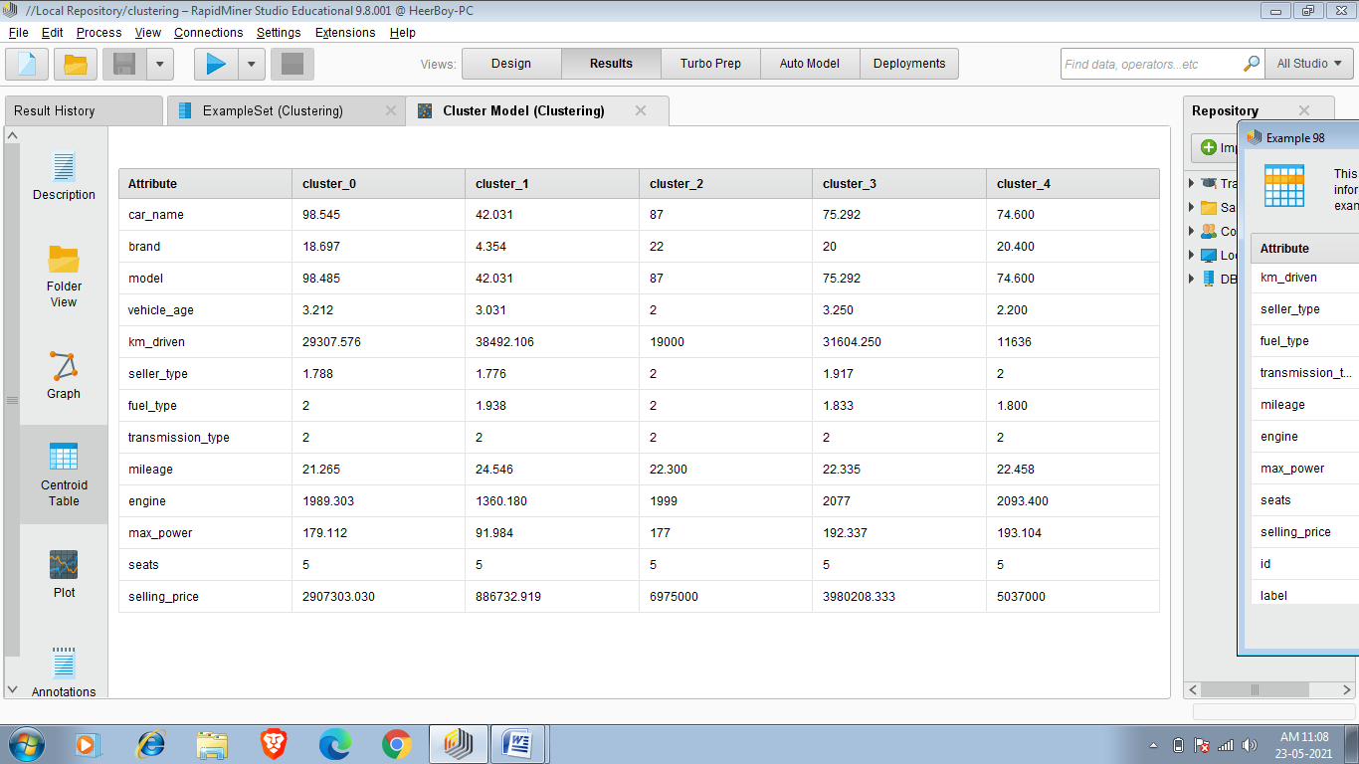

So The centroid Table That Meets my requirement I have to Just give priority To it Because That Cluster have more Relevant result ,so i can easily find my required car on that cluster.

Now i want to buy car whose price is around 10 lakh and should have more mileage ,so i have to check centroid table of all the clusters and i found that cluster_1 has mean price of 886732.919 and mean mileage of 24.546 so its more chances that i focus that i find my result in cluster_1.

Folder view:-

Now i can also see vizualition of single element in this data set i have cars data so i can see visualize view of each and every cars of different clusters.

So i want to see car whose price is near 40 lakh ,so firstly i have to see centroid table where i have o check selling_price and i found that

Cluster_3 has mean selling_price of 3080208.33 ,so its more probability that i find my result in cluster_3 .I can visualize each and every element of cluster_3 By folder View .

Below is visualization view of cars whose price around 40 lakh i can easily find my desired car.

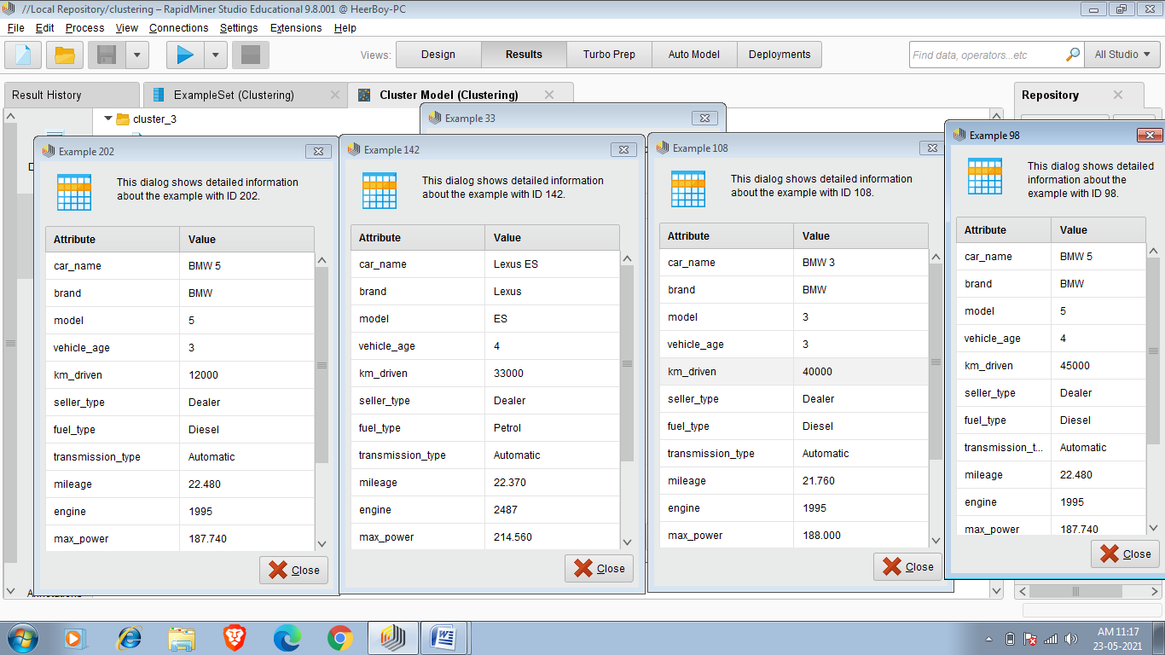

Visualization:-

I Can Also Visualize my whole dataset by Visualizations.

Visualizations has different plotting styles such lines,stepline,histogram,piechart,treemap,wordcloud etc.

Below i am showing visualization of my example set which have 229 cars that satisfy my requirements.

Wordcloud:-

Its simply shows occurerence of particular word in particular column .If a word has more occurrence it shows its bigger size in wordcloud visualizatuion

Wordcloud of column Brand:-

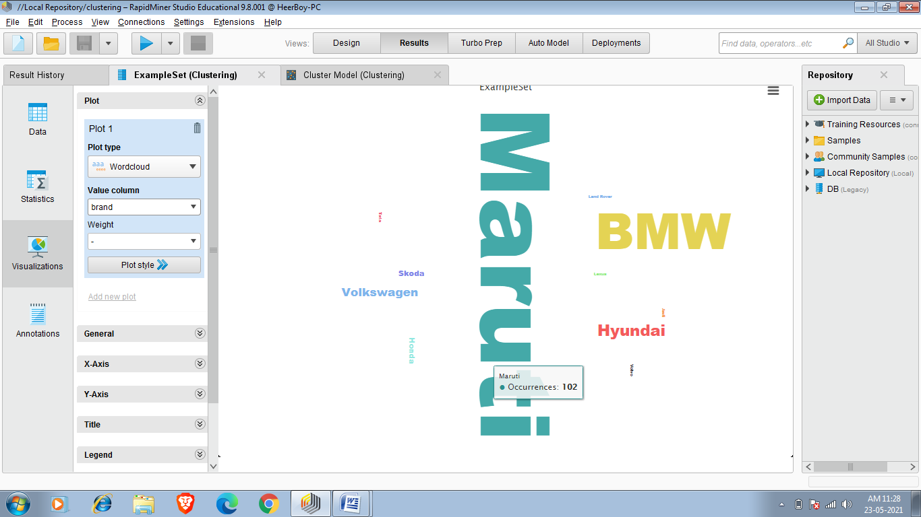

In this we easily see hat Maruti(102)and BMW (54)word cloud has bigger size which means its more probability that car’s Brand is Maruti Or BMW.

Wordcloud of column Model:-

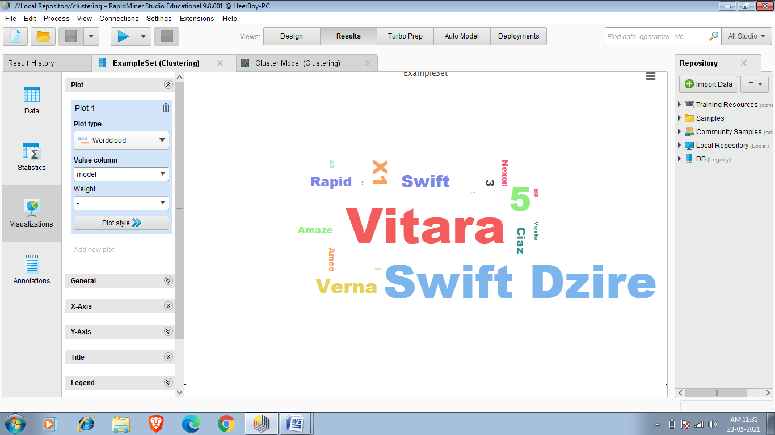

In this we easily see hat Swift Dzire(38) and Vitara(39)word cloud has bigger size which means its more probability that car’s Model is Vitara Or Swift Dzire.

Scatter Bubble:-

It is a bubble plotting of the values

Scattering of Mileage of car according to there Selling_price and taking size as engine so that it can show engine size of car.

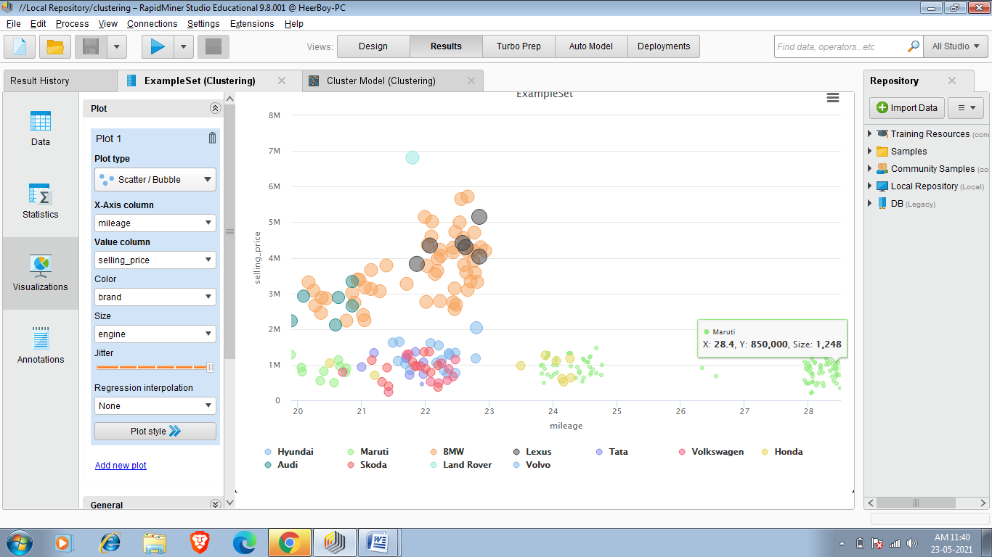

Piechart:-

We can also plot pie chart according to our requirements.

Piechart that show vehicle_age:-

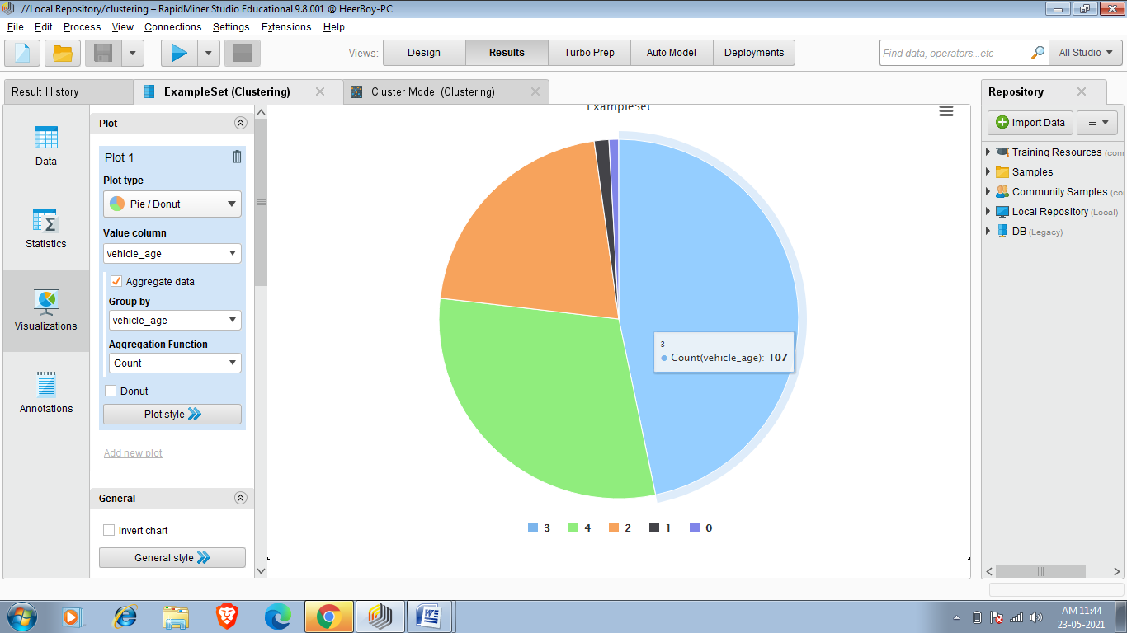

Piechart Showing Seller_type of car.

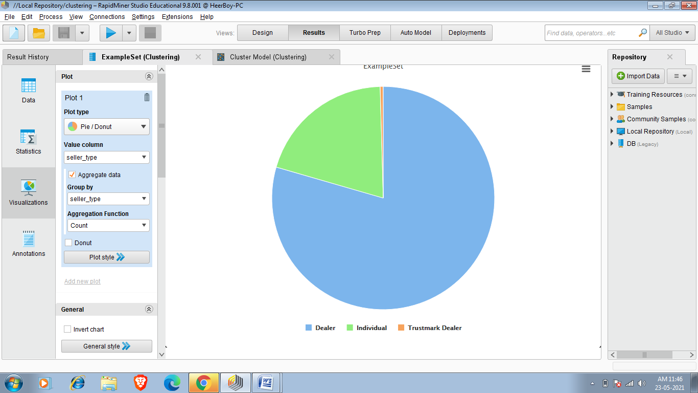

We can also plot various charts as per our requirements.

Task:- Naive Bayes Classification:

Naive Bayes is a [machine learning model](https://www.analyticssteps.com/blogs/how-do-exploratory-data-analysis-building-machine-learning-models) that is used for large volumes of data, even if you are working with data that has millions of data records the recommended approach is Naive Bayes. It gives very good results when it comes to NLP tasks such as [sentimental analysis](https://www.analyticssteps.com/blogs/sentiment-analysis-youtube-comments). It is a fast and uncomplicated [classification algorithm](https://www.analyticssteps.com/blogs/introduction-xgboost-algorithm-classification-and-regression).

 To understand the naive Bayes classifier we need to understand the Bayes theorem. So let’s first discuss the Bayes Theorem.

## ****Bayes Theorem****

It is a theorem that works on conditional probability. [Conditional probability](https://www.analyticssteps.com/blogs/conditional-probability-definition-properties-examples) is the probability that something will happen, given that something else has already occurred. The conditional probability can give us the probability of an event using its prior knowledge.

### ****Conditional probability:****

### 

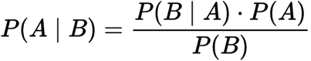

Conditional Probability

Where,

P(A): The probability of hypothesis H being true. This is known as the prior probability.

P(B): The probability of the evidence.

P(A|B): The probability of the evidence given that hypothesis is true.

P(B|A): The probability of the hypothesis given that the evidence is true.

 Implement Naive Bayes and Performance in Cardekho_cleaned(new).csv dataset.

This dataset is latest data set updated on 20 may 2021.

So to perform Naive Bayes algorithm first we read data from read CSV operator.As shown below. Required Dataset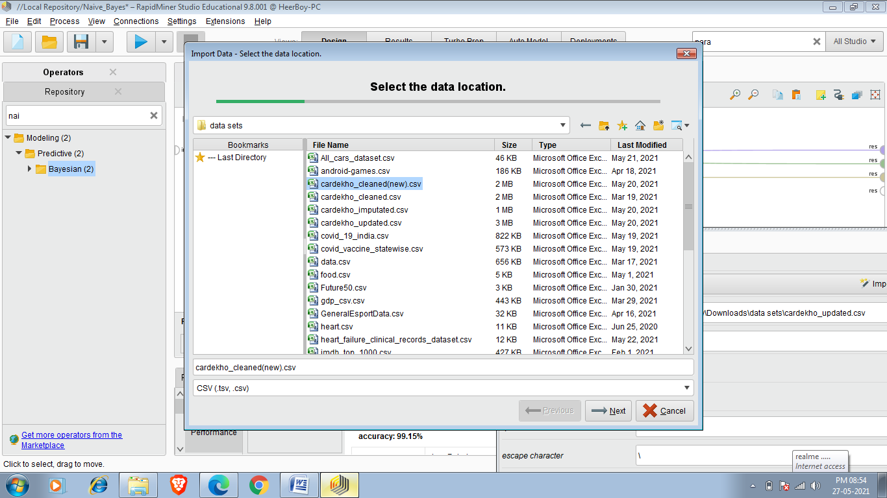

After that you can choose Attribute which you have to classify you can make that attribute as label and we can do it by 2 methods ,in first method we can change the role of attribute at importing time and another one is set role and i choosing set role and the attribute that i choose for classification of set it fuel type.

In below figure i have choosen fuel_type as label.Now classification has to done on the basis of fuel_type attribute.

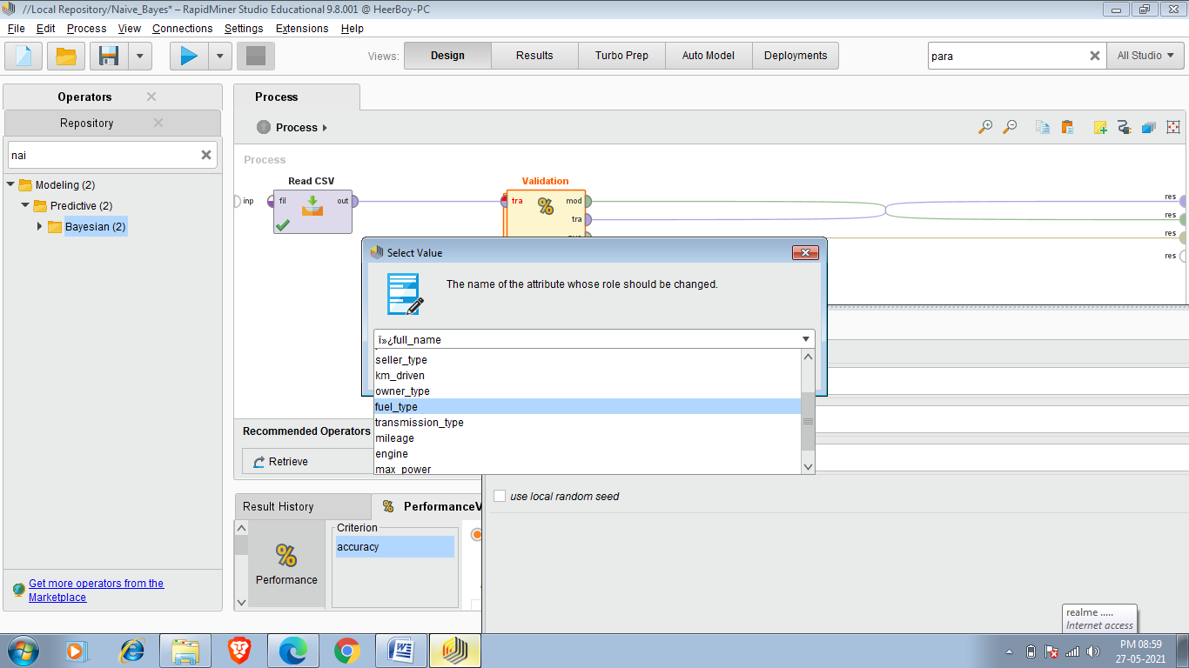

Now after setting role we have to insert Split Validation operator and the operator is shown below

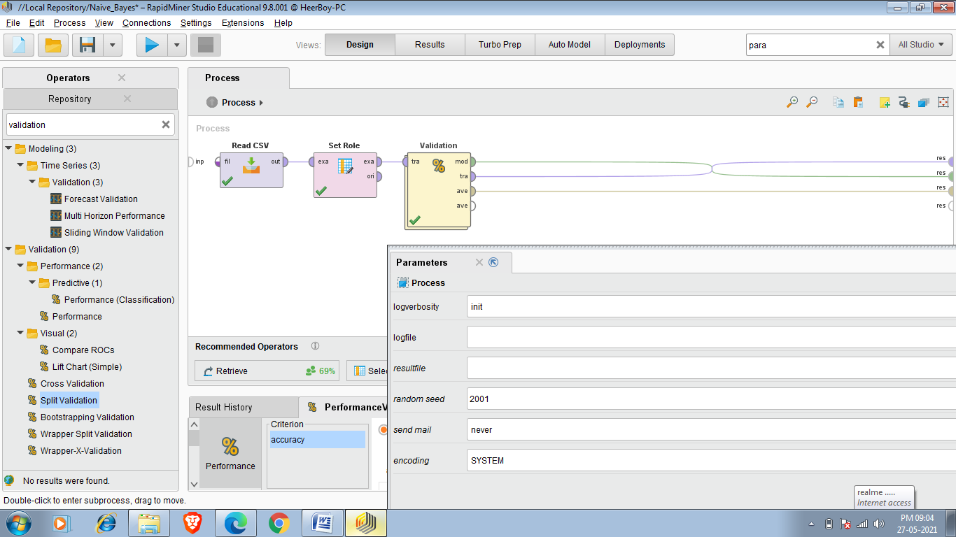

Split Validation operator performs a simple validation i.e. randomly splits up the ExampleSet into a training set and test set and evaluates the model. This operator performs a split validation in order to estimate the performance of a learning operator (usually on unseen data sets). It is mainly used to estimate how accurately a model (learnt by a particular learning operator) will perform in practice.

So now when we inserted this operator then this operator randomly splits the Example set to training and testing as shown in below figure.

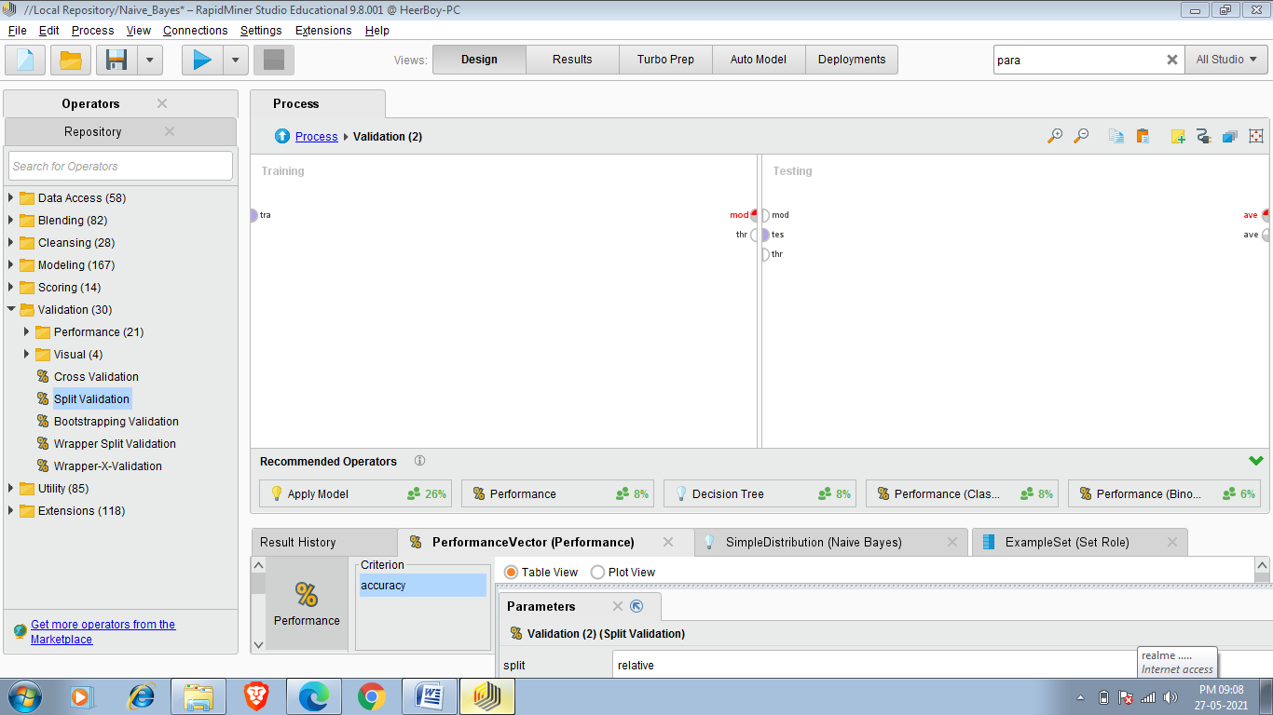

Now we have to apply Training and Testing operation so

Firstly we have to add Naive bayes to training set and then apply model and Performance to Testingset and we have to do connections as i shown in beow picture.

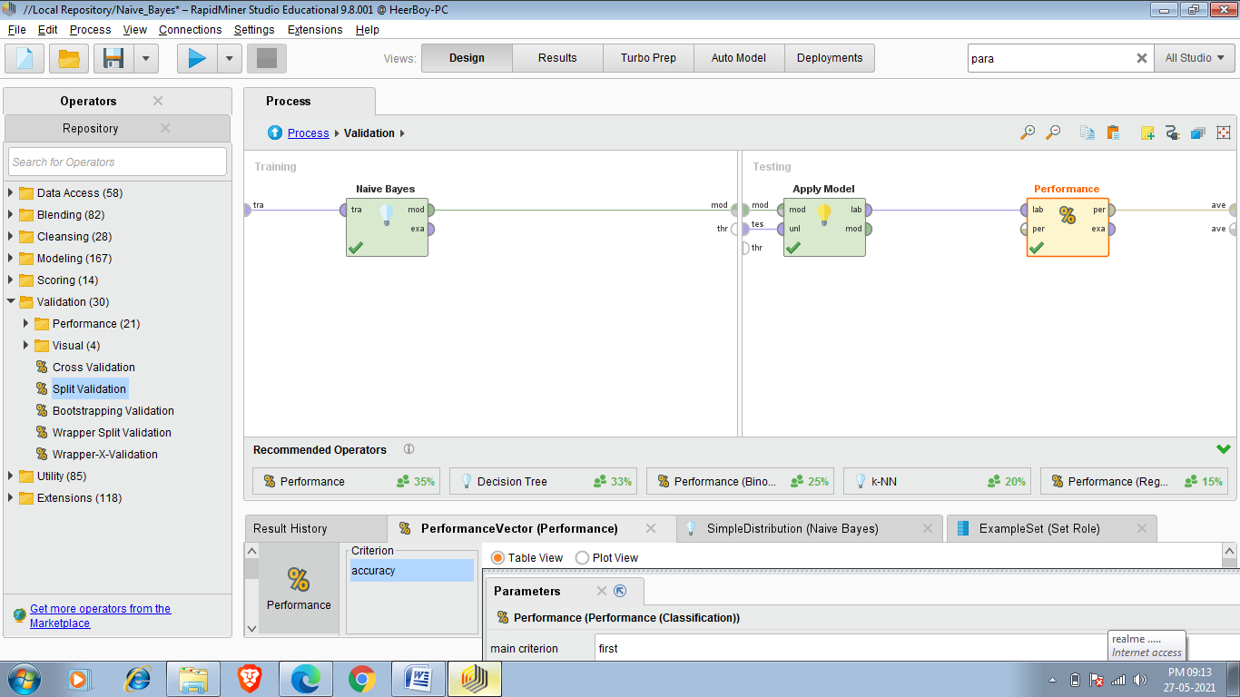

Now the process look like as shown in below picture.

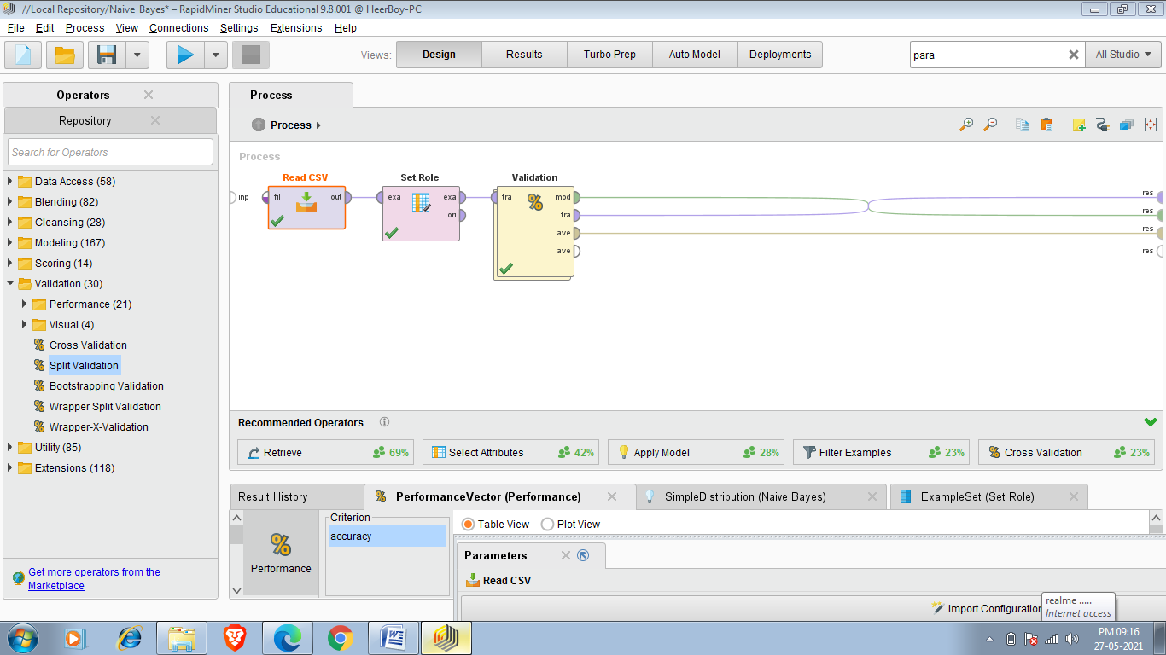

Final Result:-

Naive Bayes Classification:-

In below figure we see Naive Bayes classification classified according to the label which is Fuel_type.

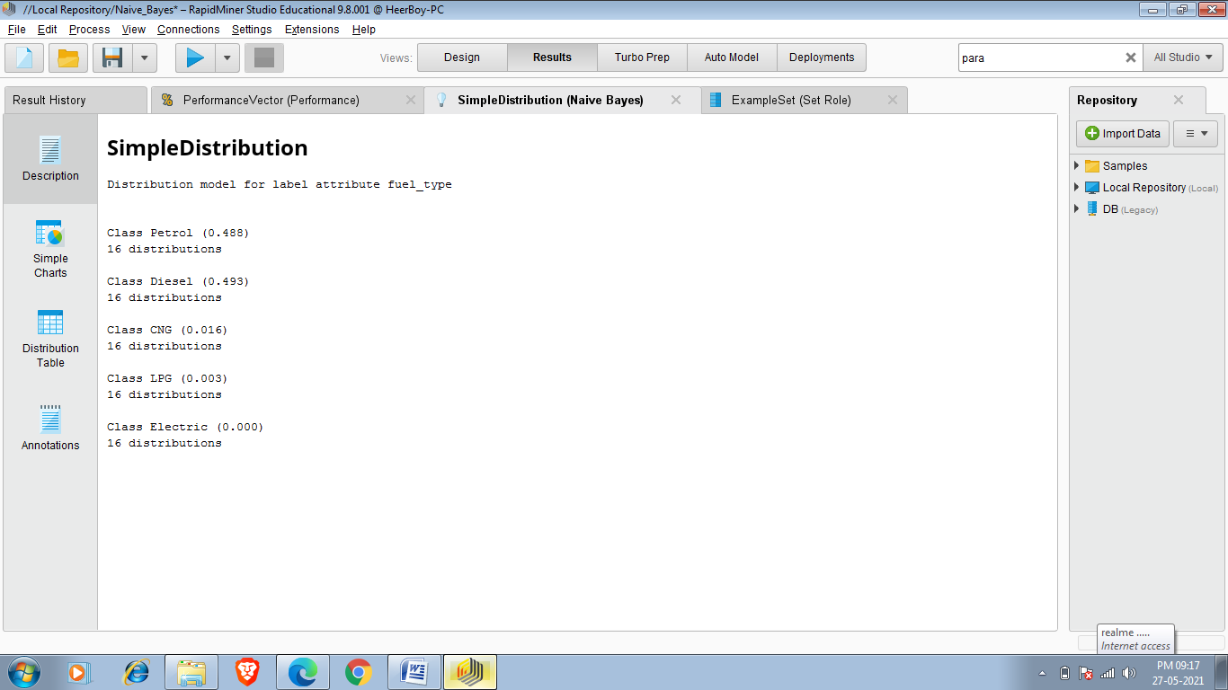

So this SimpleDistribution Simply Defines the probability and no. Of distributions.We see that petrol cars has 0.488% probability which means approximately 48.8% has fuel_type petrol in this Dataset.

DISTRIBUTED TABLE:-

This table shows the probability of different attributes when fuel_type is petrol ,diesel ,CNG,LPG or Electric.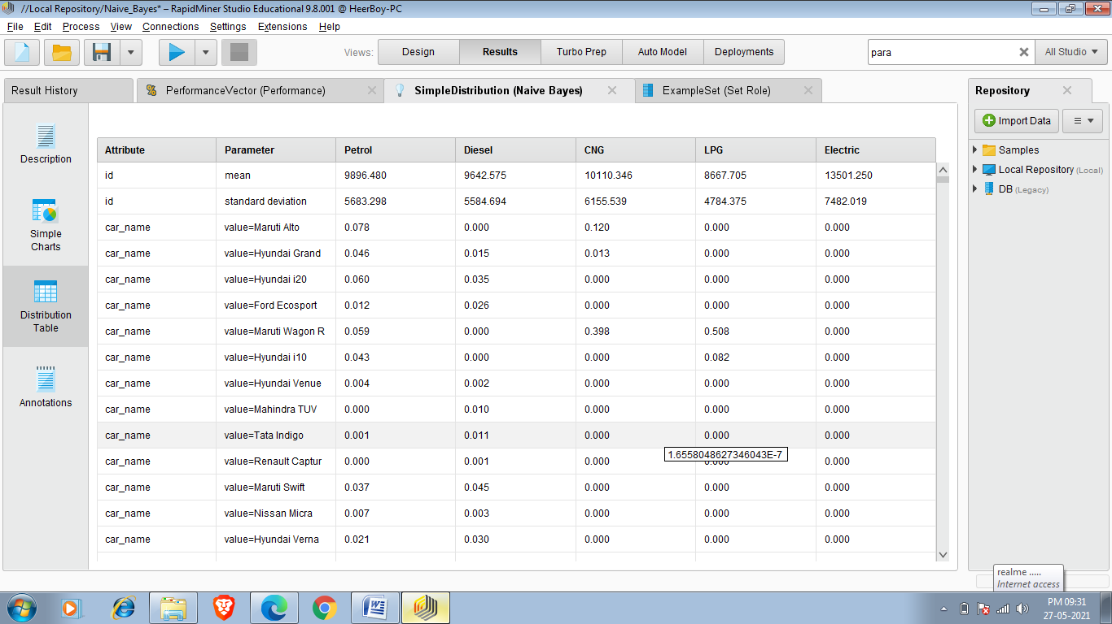

So in the above result when se to 3rd row 3rd column it is showing that probability of a car whose name is Maruti alto/ In the whole Petrol car(when car fuel_type is petrol)

And the value is 0.078% which means the car whose model is Maruti alto is only 0.078 % of whole petrol cars.

Performance:-

This operator is used for performance evaluation. It delivers a list of performance criteria values. These performance criteria are automatically determined in order to fit the learning task type.

In contrast to the other performance evaluation operators like the Performance (Classification) operator, the Performance (Binominal Classification) operator or the Performance (Regression) operator, this operator can be used for all types of learning tasks. It automatically determines the learning task type and calculates the most common criteria for that type. For more sophisticated performance calculations, you should use the operators mentioned above. If none of them meets your requirements, you can use Performance (User-Based) operator which allows you to write your own performance measure.

I also used performance operator in the above task and the results are below:-

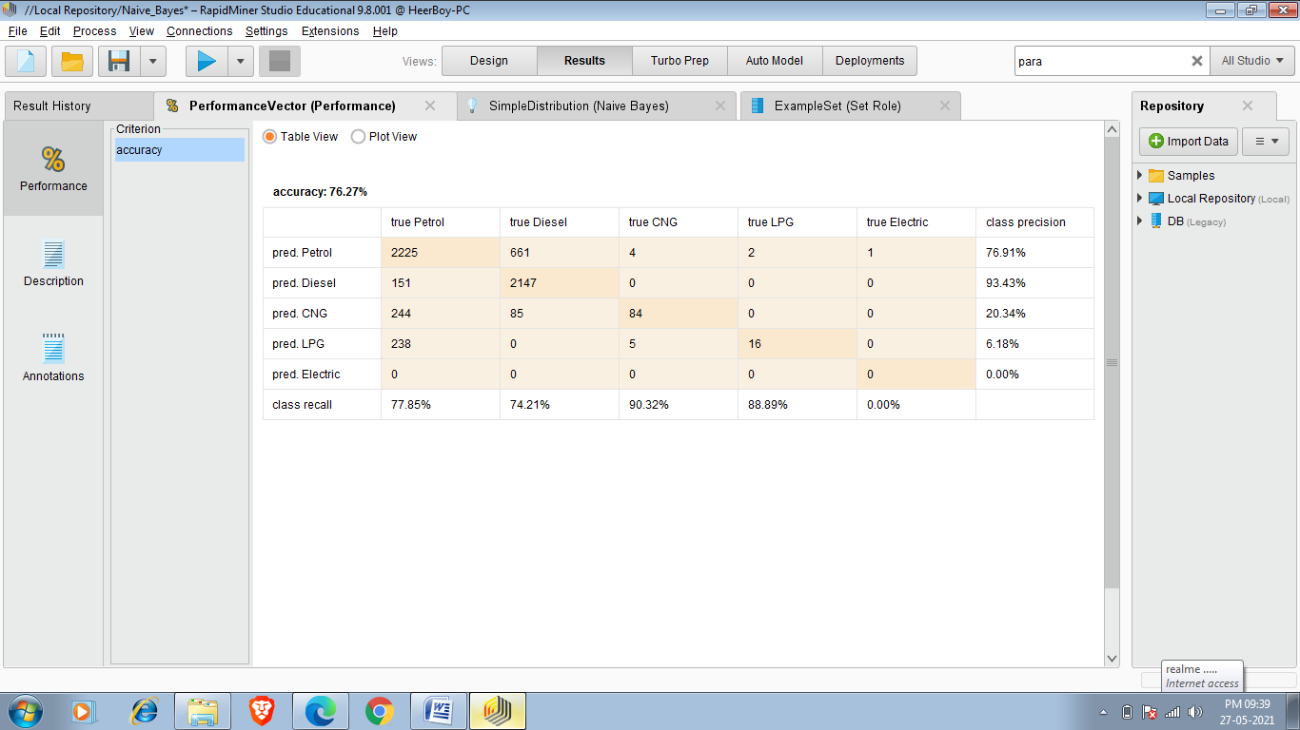

Accuracy is calculated by taking the percentage of correct predictions over the total number of examples. Correct prediction means examples where the value of the prediction attribute is equal to the value of the label attribute. If you look at the ExampleSet in the Results Workspace, you can see that there are it the accuracy of pred Petrol is 76.91% and the model has 76.27% accuracy which means it predicted 76.27% fuel_type of car rightly.